S-100 – Part 9

Portrayal
Summary of Substantive Changes in Edition 5.2.0

Change Summary | Clauses Effected
Part 9 - Portrayal
Inserted enhanced guidance for the implementation of the text drawing instruction. (NOTE: All Table numbers, and all Figure numbers from Figure 9-9, amended as a result of these changes.) | 9-11.1.11
Clarified LineStyle Class table to indicate that, even though a pen must be provided, it is not used when drawing symbolized lines without a dash component. | 9-12.1.4.2
Corrected the syntax of the hatch association for Class HatchFill. | 9-12.5.1.7
Revised entire Appendix 9-B to more fully define the SVG Profile in S-100. | 9-B

Contents

9-1 Scope 1
9-2 Conformance 1
9-3 Normative references 1
9-4 Portrayal Catalogue 2
9-5 General portrayal model 2
9-5.1 The portrayal process 3
9-6 Package overview 3
9-7 Data input Schema 4
9-7.1 Introduction 4
9-7.2 Enumerations 5
9-7.3 Coordinates 6
9-7.4 Associations 7
9-7.5 Spatial relations 8
9-7.6 Objects 9
9-7.7 Spatial objects 11
9-7.7.1 Preface 11
9-7.7.2 SpatialObject 11
9-7.7.3 Point 11
9-7.7.4 MultiPoint 11
9-7.7.5 Curve 11
9-7.7.6 CompositeCurve 13
9-7.7.7 Surface 13
9-8 Information objects 14
9-9 Feature objects 14
9-10 Portrayal processing 15
9-10.1 Portrayal input validation 16
9-11 Drawing Instructions 17
9-11.1 The concepts of drawing instructions 17
9-11.1.1 General concept 17
9-11.1.2 Portrayal Coordinate Reference Systems (CRS) 17
9-11.1.3 Viewing Groups, Viewing Group Layers and Display Mode 17
9-11.1.4 Transparency 18
9-11.1.5 Display Planes 18
9-11.1.6 Display Priorities 18
9-11.1.7 Null Instruction 18
9-11.1.8 Point Instruction 18
9-11.1.9 Line Instruction 18
9-11.1.10 Area Instruction 19
9-11.1.11 Text Instruction 19
9-11.1.12 Coverage Instruction 21
9-11.1.13 Augmented Geometry 22
9-11.2 Model of the Drawing Instruction Package 23
9-11.2.1 DisplayList 24
9-11.2.2 DrawingInstruction 24
9-11.2.3 FeatureReference 24
9-11.2.4 SpatialReference 24
9-11.2.5 AlertReference 25
9-11.2.6 NullInstruction 25
9-11.2.7 PointInstruction 25
9-11.2.8 LineInstruction 25
9-11.2.9 AreaInstruction 25
9-11.2.10 TextInstruction 25
9-11.2.11 CoverageInstruction 25
9-11.2.12 AugmentedGeometry 26
9-11.2.13 AugmentedPoint 26
9-11.2.14 AugmentedLineOrArea 26
9-11.2.15 AugmentedRay 26
9-11.2.16 AugmentedPath 26
9-11.2.17 AugmentedArea 27
9-12 Symbol Definitions 27
9-12.1 Overview 27
9-12.2 The GraphicBase package 28
9-12.2.1 Overview 28
9-12.2.2 Model 28
9-12.3 The Symbol package 32
9-12.3.1 Model 32
9-12.4 The LineStyles package 34
9-12.4.1 Model 34
9-12.5 The AreaFills package 37
9-13.5.1 Model 37
9-12.6 The Text package 40
9-12.6.1 Overview 40
9-12.6.2 Fonts 40
9-12.6.3 Model 40
9-12.7 The Coverage package 43
9-12.7.1 Overview 43
9-12.7.2 Ranges 43
9-12.7.3 Lookup Table 43
9-12.7.4 Model 44
9-13 The portrayal library 47
9-13.1 Overview 47
9-13.2 Structure 47
9-13.3 Model of the Catalogue 48
9-13.3.1 PortrayalCatalog 49
9-13.3.2 CatalogItem 49
9-13.3.3 ExternalFile 49
9-13.3.4 Description 49
9-13.3.5 Pixmaps 50
9-13.3.6 ColorProfiles 50
9-13.3.7 Symbols 50
9-13.3.8 StyleSheets 50
9-13.3.9 LineStyles 50
9-13.3.10 AreaFills 50
9-13.3.11 Fonts 50
9-13.3.12 ViewingGroups 50
9-13.3.13 ViewingGroup 51
9-13.3.14 FoundationMode 51
9-13.3.15 ViewingGroupLayers 51
9-13.3.16 ViewingGroupLayer 51
9-13.3.17 DisplayModes 51
9-13.3.18 DisplayMode 51
9-13.3.19 DisplayPlanes 51
9-13.3.20 DisplayPlane 52
9-13.3.21 Context 52
9-13.3.22 ContextParameter 52
9-13.3.23 ConstraintType 52
9-13.3.24 EnumerationType 52
9-13.3.25 TextType 53
9-13.3.26 ValidationType 53
9-13.3.27 ValidationErrorType 53
9-13.3.28 Rules 53
9-13.3.29 RuleFile 53
9-13.3.30 ParameterType 53
9-13.3.31 FileFormat 54
9-13.3.32 FileType 54
9-13.3.33 RuleType 54
9-13.4 Model of the Alert Catalogue 55
9-13.4.1 AlertCatalog 55
9-13.4.2 Messages 56
9-13.4.3 MessageItem 56
9-13.4.4 Text 56
9-13.4.5 Highlights 56
9-13.4.6 GraphicalHighlighting 56
9-13.4.7 ViewingGroupReference 56
9-13.4.8 Alerts 57
9-13.4.9 AlertItem 57
9-13.4.10 AlertInfo 57
9-13.4.11 AlertPriorities 57
9-13.4.12 AlertPrioritySelection 57
9-13.4.13 AlertPriority 57
9-13.4.14 HighlightStyle 58
9-13.5 Schema for pixmap files 58
Appendix 9-A Generating Portrayal Input XML (informative) 62
Preface 62
9-A-1 Input XML structure 62
9-A-2 Simple attributes 62
9-A-3 Complex attributes 63
9-A-4 Information types 63
9-A-5 Spatial objects 63
9-A-6 Features 63
9-A-7 Associations 64
Appendix 9-B SVG Profile (normative) 67
9-B-1 Introduction 67
9-B-2 Document structure 67
9-B-2.1 The top-level element 67
9-B-2.2 Supported elements 67
9-B-2.3 Metadata 68
9-B-3 Coordinates 69
9-B-3.1 The initial user coordinate system 69
9-B-3.2 Transformations 70
9-B-4 Styling 71
9-B-4.1 Styling-properties 71
9-B-4.2 The ‘style’ attribute 73
9-B-4.3 The ‘class’ attribute 73
9-B-4.4 CSS 74
9-B-5 Drawing Elements 75
9-B-5.1 Path 75
9-B.5.1.1 MoveTo commands 76
9-B.5.1.2 ClosePath commands 76
9-B.5.1.3 LineTo commands 76
9-B.5.1.4 Curve commands 77
9-B-5.2 Line 78
9-B-5.3 Rectangle 78
9-B-5.4 Circle 78
9-B-5.5 Ellipse 79
9-B-5.6 Polyline 79
9-B-5.7 Polygon 80

Page intentionally left blank

Scope
This part of the standard defines the models, structures and formats for a machine readable Portrayal Catalogue. The intent is for a Portrayal Catalogue to be delivered separately from product datasets such that it can be imported and interpreted to map Feature objects defined according to the Part 3 General Feature Model (GFM) into Drawing Instructions and symbolization.
The actual contents of a Portrayal Catalogue need to be defined as part of a Product Specification using the mechanism and structures defined in this part. For example a Product Specification would include a set of mapping rules, a set of symbols, linestyles, colours etc and make it available for use with product datasets.
This part includes mechanisms for portrayal of 2D vector data according to the GFM as well as Coverage data. It does not include drawing instructions and symbol structures intended for 3D portrayal. It does not include the generation of pick reports or textual reports however the approach of exposing the content to mapping rules could be implemented to generate textual or html formatted output.

Conformance
This part of the specification conforms to ISO 19117:2012 (E) according to the Annex A Abstract test suite.

Normative references
The following referenced documents are required for the application of this document. For dated references, only the edition cited applies. For undated references, the latest edition of the referenced document (including amendments) applies.
ICC Specification Version 4 – International Color Consortium
ISO 19117: 2012 (E), Geographic Information – Portrayal
W3C.REC-XSLT-1.0-19991116, XSL Transformations (XSLT) Version 1.0, W3C Recommendation 16 November 1999, <http://www.w3.org/TR/xslt>
W3C.REC-SVGTiny12-20081222, Scalable Vector Graphics (SVG) Tiny 1.2 Specification, W3C Recommendation 22 December 2008, <http://www.w3.org/TR/2008/REC-SVGTiny12-20081222>
W3C.REC-CSS2-20110607, Cascading Style Sheets Level 2 Revision 1 (CSS 2.1) Specification, W3C Recommendation 07 June 2011, <http://www.w3.org/TR/2011/REC-CSS2-20110607>
TrueType-1.66-1995, True Type Font Revision 1.66 1995, <http://www.microsoft.com/typography/SpecificationsOverview.mspx>

Portrayal Catalogue
This part of the standard describes a Portrayal Catalogue and its contents. The concept in this standard is that feature data is modelled with a focus on content and portrayal of a feature is accomplished using rules or functions that map the content to the appropriate symbols and display characteristics. This concept allows the same content to be displayed in different ways and allows the display mapping rules to be maintained without having to modify all the content data.
The Portrayal Catalogue contains portrayal functions that map the features to symbology it also contains symbol definitions, colour definitions, portrayal parameters and portrayal management concepts such as viewing groups. The goal in S-100 is to provide a mechanism where, for a given product, the Portrayal Catalogue can be delivered as data in a machine readable form such that a compliant implementation can display the product feature data using the given Portrayal Catalogue.
For the purposes of this Part, the S-100 and ISO type “CharacterString” and the XML schema type “string” are to be treated as equivalent.

General portrayal model
The general portrayal model is illustrated in figure 9.1.

Portrayal Engine

Rendering Engine
Feature Data
Portrayal functions
Drawing Instructions
Portrayal Output
Symbol Definitions
Figure 9-1 – General portrayal model
This part of S-100 defines a feature-centred function-based portrayal mechanism. Instances of features are portrayed based on portrayal functions, which make use of geometry and attribute information. The relationship between the feature instances, attributes, and the underlying spatial geometry is specified in a Product Specification based on the General Feature Model of S-100.
Portrayal information is needed to portray a dataset containing geographic data. The portrayal information is defined as drawing instructions created by specific portrayal functions. The portrayal mechanism makes it possible to portray the same dataset in different ways without altering the dataset itself.
The drawing instructions are intermediate data used by the rendering engine to produce the portayal output. During the rendering process, the rendering engine uses the symbol definitions to create the output according to the output device.
The symbol definitions contain the details of all graphical elements used for the portrayal. The model of the symbol definitions is described in this document.

The portrayal process

System Database
Feature Data
Portrayal View
XSLT Processor
Drawing Instructions
Portrayal Input XML Schema
XSLT templates
Portrayal
Functions
Drawing Instructions XML Schema
Context
User parameters
System Portrayal Engine
Figure 9-2 – Portrayal process
The system has Feature data within its internal database that needs to be portrayed. The System Portrayal Engine transforms the Feature data into drawing instructions. Drawing instructions include such things as references to symbol definitions, priority and filtering information. The drawing instructions are further processed by the rendering engine to produce the final display.
In this process, feature data needs to be exposed to the XSLT processor as XML content. The XSLT processor applies the best matching template or portrayal function to each feature. The portrayal function uses the defined logic to transform the input feature content along with related context information into drawing instructions which are output as XML.
The functionality of the System Portrayal Engine is defined in terms of XSLT. XSLT is a declarative language. An XSLT processor transforms XML input into XML output. Contextual and user parameters can be fed into the XSLT processor for use by the portrayal functions. Portrayal functions in XSLT can range from simple lookup or best match templates to complex conditional logic. XSLT is defined to work on an XML node tree however there are implementations that interface the XSLT processor directly with internal structures or relational database tables. Although there are newer versions of XSLT, XSLT 1.0 (http://www.w3.org/TR/xslt) has been chosen for this portrayal specification as the most commonly supported.
This portrayal specification defines how machine readable portrayal transformation functions are implemented as XSLT templates disseminated in XSL files. Since XSLT is defined to operate on XML and produce XML the XML input and output are described as part of this specification. A conformant System Portrayal Engine must operate consistently with XSLT in order to process the machine readable XSL files and produce equivalent output.

Package overview
The following diagram shows the packages for implementing this standard.
The InputSchema describes how data is presented to the portrayal engine (XSLT processor). The Presentation package includes two subpackages one describing the Portrayal Catalogue structure the other describing the drawing instructions. Drawing instructions are the output of the portrayal engine (XSLT processor).
The SymbolDefinitions package describes the graphic primitives used for portrayal.
The portrayal engine is using standard XSLT. There is no package describing this part of the portrayal.
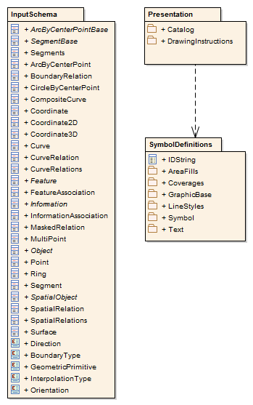
Figure 9-3 – Packages

Data input Schema

Introduction
The data input Schema describes how data should be presented to the XSLT processor. Encoded data can be transformed to an XML document or a presentation of such a document, for example a DOM-tree. It is also possible to model the data to look like XML and use a special software interface to present such data to the XSLT processor.
Whichever method is used, this Schema describes how the data must be organized. In this standard only the base types are described. These types should be used along with a product‘s Feature Catalogue to generate the input XML for portrayal processing, as described in Annex A.
NOTE It is assumed for the examples in this section that types of this Schema are in the namespace s100.

Enumerations
For the use in this Schema the following enumeration types are defined:
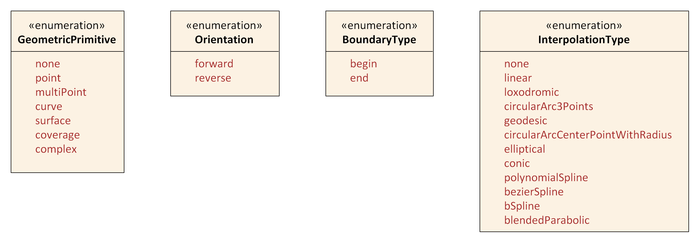
Figure 9-4 – Input Schema Enumerations
GeometricPrimitive
This enumeration describes the type of geometric primitive that is used by a feature object. If the feature object uses different geometric primitives the value Complex has to be used.
<xs:simpleType name="GeometricPrimitive">
<xs:restriction base="xs:string">
<xs:enumeration value="None"/>
<xs:enumeration value="Point"/>
<xs:enumeration value="MultiPoint"/>
<xs:enumeration value="Curve"/>
<xs:enumeration value="Surface"/>
<xs:enumeration value="Coverage"/>
<xs:enumeration value="Complex"/>
</xs:restriction>
</xs:simpleType>
Orientation
The enumeration Orientation is used to specify the orientation of a referenced geometry that is used by a feature object or by a complex curve.
<xs:simpleType name="Orientation">
<xs:restriction base="xs:string">
<xs:enumeration value="Forward"/>
<xs:enumeration value="Reverse"/>
</xs:restriction>
</xs:simpleType>
BoundaryType
This enumeration describes the type of a topologic boundary.
<xs:simpleType name="BoundaryType">
<xs:restriction base="xs:string">
<xs:enumeration value="Begin"/>
<xs:enumeration value="End"/>
</xs:restriction>
</xs:simpleType>
InterpolationType
This enumeration describes the mathematical interpolation method between two control points in a line segment. Note that the methods depend on the underlying coordinate reference system and not all of them are valid for all types of CRS. The Product Specification should specify the details of the use of interpolation.
<xs:simpleType name="InterpolationType">
<xs:restriction base="xs:string">
<xs:enumeration value="None"/>
<xs:enumeration value="Linear"/>
<xs:enumeration value="Loxodromic"/>
<xs:enumeration value="CircularArc3Points"/>
<xs:enumeration value="Geodesic"/>
<xs:enumeration value="CircularArcCenterPointWithRadius"/>
<xs:enumeration value="Elliptical"/>
<xs:enumeration value="Conic"/>
<xs:enumeration value="PolynomialSpline"/>
<xs:enumeration value="BezierSpline "/>
<xs:enumeration value="BSpline"/>
<xs:enumeration value="BlendedParabolic"/>
</xs:restriction>
</xs:simpleType>

Coordinates
In case that coordinates have to be presented to the XSLT processor the following types have to be used.
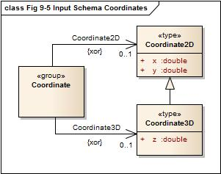
Figure 9-5 – Input Schema Coordinates
The types Coordinate2D and Coordinate3D are for a simple coordinate tuple. They are defined as:
<xs:complexType name="Coordinate2D">
<xs:sequence>
<xs:element name="x" type="xs:double"/>
<xs:element name="y" type="xs:double"/>
</xs:sequence>
</xs:complexType>
<xs:complexType name="Coordinate3D">
<xs:complexContent>
<xs:extension base="Coordinate2D">
<xs:sequence>
<xs:element name="z" type="xs:double"/>
</xs:sequence>
</xs:extension>
</xs:complexContent>
</xs:complexType>
Note that the type Coordinate3D is an extension of the type Coordinate2D.
Example:
<s100:Coordinate2D>
<s100:x>9.12345</s100:x>
<s100:y>52.56789</s100:y>
</s100:Coordinate2D>
And
<s100:Coordinate2D>
<s100:x>9.12345</s100:x>
<s100:y>52.56789</s100:y>
<s100:z>12.5</s100:z>
</s100:Coordinate2D>
A group Coordinate is defined where coordinate tuples can be used. The use of 2D or 3D tuples is mutually exclusive.
<xs:group name="Coordinate">
<xs:choice>
<xs:element name="Coordinate2D" type="Coordinate2D"/>
<xs:element name="Coordinate3D" type="Coordinate3D"/>
</xs:choice>
</xs:group>

Associations
According to the general feature model there are two types of associations:
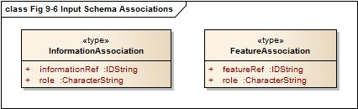
Figure 9-6 – Input Schema Associations
For each association a separate type is defined in the Schema:
<xs:complexType name="InformationAssociation">
<xs:attribute name="informationRef" type="IDString" use="required"/>
<xs:attribute name="role" type="xs:string" use="required"/>
</xs:complexType>
<xs:complexType name="FeatureAssociation">
<xs:attribute name="featureRef" type=" IDString " use="required"/>
<xs:attribute name="role" type="xs:string" use="required"/>
</xs:complexType>
The attributes informationRef and featureRef correspond to the attribute id of the referenced information respective feature object. See the section on objects for more details.
Each S100_FC_InformationAssociation and S100_FC_FeatureAssociation defined in a Feature Catalogue describes a subtype of InformationAssociation and FeatureAssociation respectively. These subtypes may define additional attributes of the association; these attributes should be included in the input XML as described in Annex A.

Spatial relations
In the general feature model different relations are modelled between feature types and spatial types but also between spatial types. For such relations the following types are defined by this Schema.
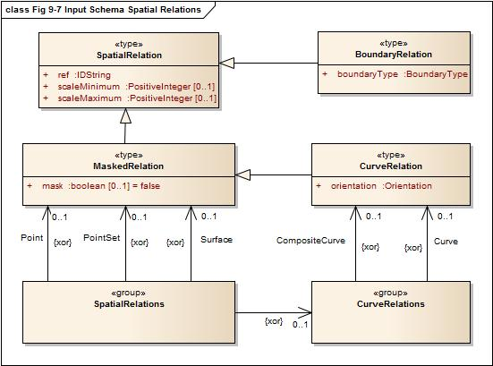
Figure 9-7 – Input Schema Spatial Relations
The type SpatialRelation is the base type for all relations to spatial objects. The ref attribute corresponds to the attribute id of the spatial object.
<xs:complexType name="SpatialRelation">
<xs:attribute name="ref" type=" IDString " use="required"/>
<xs:attribute name="scaleMinimum" type="xs:positiveInteger" use="required"/>
<xs:attribute name=" scaleMaximum " type="xs:positiveInteger" use="required"/>
</xs:complexType>
The other relation types are derived from this type and add information according to the specific use of that relation. The type MaskedRelation adds an attribute mask that specifies if a referenced spatial object should not be used for portrayal.
<xs:complexType name="MaskedRelation">
<xs:complexContent>
<xs:extension base="SpatialRelation">
<xs:attribute name="mask" type="xs:boolean" default="false"/>
</xs:extension>
</xs:complexContent>
</xs:complexType>
Note that the attribute mask is not mandatory but has a default value for the case of its absence.
The type BoundaryRelation adds a boundary type to the relation and is used when the relation describes a topological relation, for example the relation to a bounding node of a curve.
<xs:complexType name="BoundaryRelation">
<xs:complexContent>
<xs:extension base="SpatialRelation">
<xs:attribute name="boundaryType" type="BoundaryType" use="required"/>
</xs:extension>
</xs:complexContent>
</xs:complexType>

The type CurveRelation is used whenever a curve is referenced by a spatial relation since it is necessary to specify if the curve is used in the same direction as it is defined or in the reverse order. The type is derived from MaskedRelation since each curve can be a subject of masking.
<xs:complexType name="CurveRelation">
<xs:complexContent>
<xs:extension base="MaskedRelation">
<xs:attribute name="orientation" type="Orientation" use="required"/>
</xs:extension>
</xs:complexContent>
</xs:complexType>
Two groups are defined for Spatial relations. One group defines the possible relations to curves; the other defines all possible spatial relations.
<xs:group name="CurveRelations">
<xs:choice>
<xs:element name="Curve" type="CurveRelation"/>
<xs:element name="CompositeCurve" type="CurveRelation"/>
</xs:choice>
</xs:group>
<xs:group name="SpatialRelations">
<xs:choice>
<xs:element name="Point" type="MaskedRelation"/>
<xs:element name="PointSet" type="MaskedRelation"/>
<xs:element name="Surface" type="MaskedRelation"/>
<xs:group ref="CurveRelations"/>
</xs:choice>
</xs:group>

How these groups are used is demonstrated in Annex A.

Objects
All objects in a data set are based on the type Object which carries the common properties of all objects. Each object needs to be uniquely identifiable within a data set. This is done by the attribute id.
An optional association to Information is provided. When an information association is present, the code of an information association defined in the Feature Catalogue should be used as the element name in place of associatedInformation - see Appendix 9-A for more information
<xs:complexType name="Object" abstract="true">
<xs:sequence>
<xs:element name="associatedInformation" type="InformationAssociation" minOccurs="0"
maxOccurs="unbounded"/>
<!—When generating input XML the base schema should be extended to provide a substitution group for each information association defined in the Feature Catalogue. For example, if the Feature Catalogue defines an information association having a code of SpatialAssociation, the base schema should be extended with:
<xs:element name="SpatialAssociation" substitutionGroup="associatedInformation"/>
-->
</xs:sequence> <xs:attribute name="id" type="IDString" use="required"/>
</xs:complexType>
Note that the type of the identifier is IDString to be as general as possible with respect to different methods used for identification. The characters allowed in this string are 0-9a-zA-Z.
<xs:simpleType name="IDString">
<xs:restriction base="xs:string">
<xs:minLength value="1"/>
<xs:pattern value="[0-9a-zA-Z_]*"/>
</xs:restriction>
</xs:simpleType>

The model of all objects is given in Figure 9-8 below.
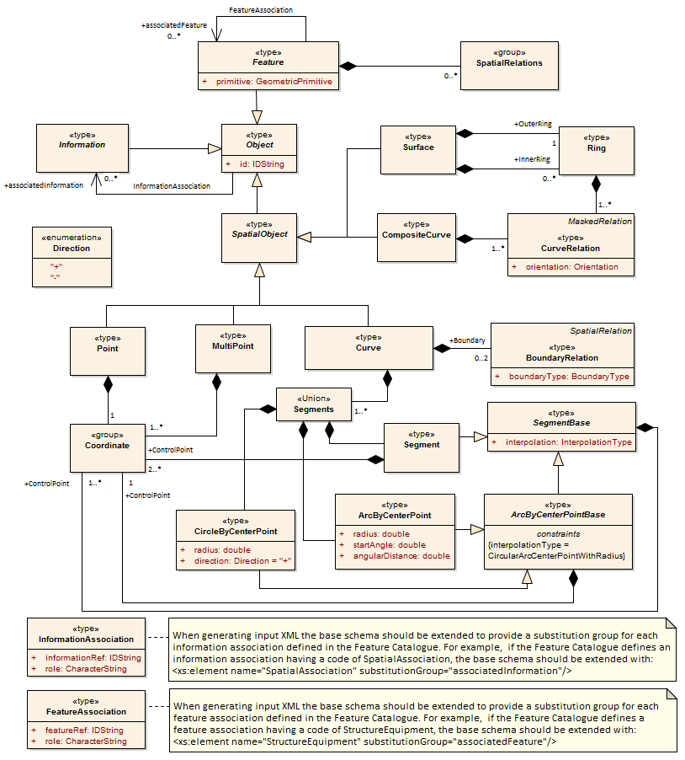
Figure 9-8 – Input Schema Objects

Spatial objects

Preface
Spatial objects in a data set carry the geometric location of a feature object. The following types are supported by this standard:
- Point
- MultiPoint
- Curve
- Composite curve
- Surface
Attributes are not permitted for spatial objects by the GFM. All types are derived from the type Object, meaning they have an identifier and may have associated information such as spatial quality.

SpatialObject
SpatialObject is an abstract class which serves as the base class for all spatial objects.
<xs:complexType name="SpatialObject" abstract="true">
<xs:complexContent>
<xs:extension base="Object">
</xs:complexContent>
</xs:complexType>

Point
A point carries a single coordinate tuple, 2D or 3D. The definition looks like.
<xs:complexType name="Point">
<xs:complexContent>
<xs:extension base="SpatialObject">
<xs:sequence>
<xs:group ref="Coordinate"/>
</xs:sequence>
</xs:extension>
</xs:complexContent>
</xs:complexType>
Note that the group Coordinate is used within the definition to allow both Coordinate2D and Coordinate3D elements

MultiPoint
Similar to Point this type defines point geometry for a feature object. The difference is that a set of tuples can be defined. Therefore maxOccurs is set to unbounded.
<xs:complexType name="MultiPoint">
<xs:complexContent>
<xs:extension base="SpatialObject">
<xs:sequence>
<xs:group ref="Coordinate" minOccurs="1" maxOccurs="unbounded"/>
</xs:sequence>
</xs:extension>
</xs:complexContent>
</xs:complexType>

Curve
Curves describe the line geometry of a feature object. They are made of segments where each segment has a sequence of control points and an interpolation method. The latter defines the geometry between the control points according to the used coordinate reference system. There are two special types of segments:
- ArcByCenterPoint
A circular arc defined by a center point and a radius. The beginning of the arc is defined by the start angle and the length of the arc is defined by the angular length. This length is a signed quantity defining the direction of the arc: positive means clockwise.
- CircleByCenterPoint
A circle defined by a center point and a radius.
The abstract type SegmentBase defines a sequence of control points and the attribute for the interpolation type:

<xs:complexType name="SegmentBase" abstract="true">
<xs:sequence>
<xs:element name="ControlPoint" type="Coordinate2D" minOccurs="1" maxOccurs="unbounded"/>
</xs:sequence>
<xs:attribute name="interpolation" type="InterpolationType" use="required"/>
</xs:complexType>
From this type the type Segment is derived by restricting the number of control points to at least two:
<xs:complexType name="Segment">
<xs:complexContent>
<xs:restriction base="SegmentBase">
<xs:sequence>
<xs:element name="ControlPoint" type="Coordinate2D" minOccurs="2" maxOccurs="unbounded"/>
</xs:sequence>
</xs:restriction>
</xs:complexContent>
</xs:complexType>
For the “by center point” segments the abstract base type is also derived from SegmentBase restricting the number of control points to exact 1 and fixes the value of the attribute interpolation.
<xs:complexType name="ArcByCenterPointBase" abstract="true">
<xs:complexContent>
<xs:restriction base="SegmentBase">
<xs:sequence>
<xs:element name="ControlPoint" type="Coordinate2D" minOccurs="1" maxOccurs="1"/>
</xs:sequence>
<xs:attribute name="interpolation" type="InterpolationType" use="required"
fixed="CircularArcCenterPointWithRadius"/>
</xs:restriction>
</xs:complexContent>
</xs:complexType>
The ArcByCenterPoint is then an extension of this type adding attributes for radius, start angle and angular length.
<xs:complexType name="ArcByCenterPoint">
<xs:complexContent>
<xs:extension base="ArcByCenterPointBase">
<xs:attribute name="radius" type="xs:double" use="required"/>
<xs:attribute name="startAngle" type="xs:double" use="required"/>
<xs:attribute name="angularDistance" type="xs:double" use="required"/>
</xs:extension>
</xs:complexContent>
</xs:complexType>
The CircleByCenterPoint type is very similar. The attribute start angle is not defined since it is meaningless. The direction is here defined by the attribute direction which has values ‘+’ or ‘-‘.
<xs:simpleType name="Direction">
<xs:restriction base="xs:string">
<xs:enumeration value="+"/>
<xs:enumeration value="-"/>
</xs:restriction>
</xs:simpleType>
<xs:complexType name="CircleByCenterPoint">
<xs:complexContent>
<xs:extension base="ArcByCenterPointBase">
<xs:attribute name="radius" type="xs:double" use="required"/>
<xs:attribute name="direction" type="Direction" default="+"/>
</xs:extension>
</xs:complexContent>
</xs:complexType>
A group is defined that allows the use of the different type of segments.
<xs:group name="Segments">
<xs:choice>
<xs:element name="Segment" type="Segment"/>
<xs:element name="ArcByCenterPoint" type="ArcByCenterPoint"/>
<xs:element name="CircleByCenterPoint" type="CircleByCenterPoint"/>
</xs:choice>
</xs:group>
The type Curve finally combines a sequence of segments with the topological boundary. The topological boundary of a curve is the beginning and end node implemented by a Point object.
<xs:complexType name="Curve">
<xs:complexContent>
<xs:extension base="SpatialObject">
<xs:sequence>
<xs:element name="Boundary" type="BoundaryRelation" minOccurs="0" maxOccurs="2"/>
<xs:group ref="Segments" minOccurs="1" maxOccurs="unbounded"/>
</xs:sequence>
</xs:extension>
</xs:complexContent>
</xs:complexType>

CompositeCurve
A composite curve describes the line geometry of a feature object just like a ‘simple’ curve. But instead of using coordinates to define the geometry it is using a sequence of other curves, including other composite curves. With other words it is a sequence of relations to other curves.
<xs:complexType name="CompositeCurve">
<xs:complexContent>
<xs:extension base="SpatialObject">
<xs:sequence>
<xs:group ref="CurveRelations" minOccurs="1" maxOccurs="unbounded"/>
</xs:sequence>
</xs:extension>
</xs:complexContent>
</xs:complexType>

Surface
Surfaces describe the area geometry of a feature object. The surface itself is defined by its boundary. The boundary consists of an outer ring and optionally a number of inner rings. The inner rings describe holes in the area. Each ring is a closed polygon made from one or many curves. That means that a ring is very similar to a composite curve but unlike the composite curve it is not derived from SpatialObject because it does not need to be identifiable. The definition of a ring simply looks like:
<xs:complexType name="Ring">
<xs:group ref="CurveRelations" minOccurs="1" maxOccurs="unbounded"/>
</xs:complexType>
And the definition of a surface finally is:
<xs:complexType name="Surface">
<xs:complexContent>
<xs:extension base="SpatialObject">
<xs:sequence>
<xs:element name="OuterRing" type="Ring"/>
<xs:element name="InnerRing" type="Ring" minOccurs="0" maxOccurs="unbounded"/>
</xs:sequence>
</xs:extension>
</xs:complexContent>
</xs:complexType>

Information objects
Information object are identifiable and sharable pieces of information within a data set. In the model an abstract type Information is derived from the type Object. Although no additional properties are added, this type is useful for semantic reasons.
<xs:complexType name="Information" abstract="true">
<xs:complexContent>
<xs:extension base="Object"/>
</xs:complexContent>
</xs:complexType>

Feature objects
Feature objects are abstractions of real world phenomena. This Schema defines the abstract base type for any feature type. The type Feature is derived from Object and adds a sequence of spatial relations and a geometric primitive attribute to the properties from the base class, as well as optional associations to other features.
When an association is present, the code of an feature association defined in the Feature Catalogue should be used as the element name in place of associatedFeature - see Annex A for more information.
<xs:complexType name="Feature" abstract="true">
<xs:complexContent>
<xs:extension base="Object">
<xs:sequence>
<xs:group ref="SpatialRelations" minOccurs="0" maxOccurs="unbounded"/>
<xs:element name="associatedFeature" type="FeatureAssociation" minOccurs="0"
maxOccurs="unbounded"/>
<!—When generating input XML the base schema should be extended to provide a substitution group for each feature association defined in the Feature Catalogue. For example, if the Feature Catalogue defines a feature association having a code of StructureEquipment, the base schema should be extended with:
<xs:element name="StructureEquipment" substitutionGroup="associatedFeature"/>
-->
</xs:sequence>
<xs:attribute name="primitive" type="GeometricPrimitive" use="required"/>
</xs:extension>
</xs:complexContent>
</xs:complexType>

Portrayal processing
This specification is referencing XSLT 1.0 which is a W3C recommendation, http://www.w3.org/TR/xslt
XSLT uses XPath 1.0 to address components of a document. http://www.w3.org/TR/xpath/
XSLT (XSL Transformations) is a language expressed as a well formed XML document. The intended purpose of using XSLT in portrayal is to transform the data into drawing instructions. Since XSLT is expressed in XML it is useful for interchange as a machine readable transformation language. XSLT is widely used across many domains but is perhaps most commonly used to transform XML documents into HTML for web page displays. There are many tutorials, books and reference material available for XSLT. There are also several web sites where questions can be posted and examples can be found.
XSLT uses templates to process nodes in the input XML tree and generate nodes as output XML, other SGML formats or even plain text. There are two types of templates a matching template and a named template.
Matching templates use a matching expression using XPATH to specify what elements in the input document should be processed by that template. XPATH (XML Path Language) is an expression language used to address or find components in an XML document. The path capability makes it especially useful when dealing with a hierarchy of content such as nested complex attributes. Only one matching template can match an element from the input document. Matching templates have a built in priority calculation and conflict resolution method that is used to determine which one to use in the case where multiple templates match the same element. Priority numbers can be explicitly assigned as an attribute of a matching template in order to override the default conflict resolution behaviour.
Named templates are called by another template along with the data to be processed. Named templates can also have parameters. These are useful for formatting or other operations that are commonly used in a transformation. A named template can even call itself (recursion), which can be useful for operations such as string token parsing.
A template can loop over a set of nodes that match an XPath expression using an “xsl:apply-templates “ or “xsl:for-each” instruction element. The nodes can also be sorted before being processed. Conditional processing is available by using a simple “xsl:if” instruction or an “xsl:choose” instruction. The choose instruction allows a set of expressions to be tested such that only the first one matching is processed and if no match is found an optional otherwise statement is used to handle a default. This is useful for testing enumerated data such that a different output is generated depending upon the enumeration value.
XSLT also includes the ability to have parameters passed at the top level and accessed within any of the templates. These parameters can be useful to provide contextual information to the transformation. There are also variables in XSLT but they can only be assigned data as part of their definition, unlike other languages where variables can be reassigned. Variables are useful to collect data or decision results that can be passed as parameters to another template or used in conditional statements.
XSLT can include or import other XSLT documents. This capability can be useful for management of templates and reuse of templates by multiple top level XLST documents.
Examples
Given the example XML below
<BeaconCardinal id="2">
<s100:Point ref="3"/>
<categoryOfCardinalMark>3</categoryOfCardinalMark>
</BeaconCardinal>
<BeaconCardinal id="3">
<s100:Point ref="3"/>
<categoryOfCardinalMark>2</categoryOfCardinalMark>
</BeaconCardinal>
A simple matching XSLT template used as a portrayal function
<xsl:template match="BeaconCardinal">
<!—This is a comment. This template matches a BeaconCardinal node and the body of the template can examine data and output results -->

</xsl:template>

The above template will be used to process all of the BeaconCardinal objects.
The choose instruction can be used to do conditional processing within the template.
<xsl:template match="BeaconCardinal">

<xsl:choose>
<xsl:when test="categoryOfCardinalMark = '2'">
<!-- Output symbol for BeaconCardinal categoryOfCardinalMark =2 here -->
</xsl:when>
<xsl:when test="categoryOfCardinalMark = '3'">
<!-- Output symbol for BeaconCardinal categoryOfCardinalMark =3 here -->
</xsl:when>
<xsl:otherwise>
<!-- Output default symbol here -->
</xsl:otherwise>
</xsl:choose>

</xsl:template>

A more advanced XPath expression can be used to refine the match.
<xsl:template match="BeaconCardinal[categoryOfCardinalMark=2] ">
<!—This is a comment. Output symbol for BeaconCardinal categoryOfCardinalMark =2 here -->

</xsl:template>

Portrayal input validation
The Portrayal Catalogue describes each valid portrayal input parameter (context parameter) and may provide associated validation rules and value constraints. The validation rules are XPath 1.0 Boolean expressions; or W3C XML Standard – Part 2, Appendix F regular expressions. The rules support validation of the user input to portrayal, and the constraints support eliminating free-form input while supporting a machine-readable user interface (UI).
To ensure user-entered values are reasonable prior to use as portrayal input, the validation rules may:
- Ensure input values are within the expected value domain;
- Ensure input values conform to an expected pattern (for example, ###-####); and
- Ensure input values are logically consistent with respect to one another.
Additionally, context parameters and validation rules can be enabled or disabled based on XPath 1.0 Boolean expressions, supporting conditional validation and a machine-readable UI. For instance, validation of the S-101 Shallow Contour parameter may be disabled when the value of the Two Shades parameter is true.
Context parameters with an associated constraint are restricted to a set of enumerated values. This allows applications to eliminate free-form input for these parameters; and enhances the machine-readable UI by associating a label with each enumerated value (for example, “On“ associated with the value “1“).
Applications support portrayal input validation by:
- Using the constraints to restrict user input.
- On each change to a context parameter value:
  - Generate a simple XML document encoding the context parameter values:
<TwoShades>true</TwoShades> <!-- etc.-->
  - For each enabled validation of each enabled context parameter:
    - Ensure XPath rules evaluate to true;
    - Ensure regular expressions match.
XPath validations should all evaluate to true, and regex validations should all match prior to processing the portrayal rules. If an enabled validation evaluates to false or doesn’t match then no further portrayal processing should be performed and error messages associated with failed validation rules should be activated.

Drawing Instructions

The concepts of drawing instructions

General concept
The output of the portrayal engine is a set of drawing instructions, which link the feature type to a symbol and/or alert reference. The geometry is either taken from the feature type or can be generated by the portrayal functions. The latter is supported by the concept of augmented geometry.

Portrayal Coordinate Reference Systems (CRS)
In this context coordinate reference systems refer to the portrayal geometry only.
There are different CRS related to the portrayal:
- Geographic CRS
- Portrayal CRS
- Local CRS
- Line CRS
- Area CRS
- Tile CRS
- Hatch CRS
Geographic CRS are used in the geographic dataset that are portrayed. They will be mapped by means of projections and affine transformation to the Portrayal CRS. Nevertheless rotations of symbols may be still defined relative to the North-Axis of the Geographic CRS.
The Portrayal CRS defines the coordinates at the output device, for example a screen or pixmap.
Line symbols have two kinds of coordinate reference systems. The line coordinate reference system is a non-Cartesian 2-axis coordinate system. The x-axis is following the line geometry and the y-axis is perpendicular to the geometry of the curve. This CRS allows for the specification of line widths,offsets and symbols following the geometry. The second kind of coordinate reference system is a local Cartesian coordinate reference system which is defined for every location along a curve. This coordinate reference system has an x-axis that is tangential to the curve and a y-axis perpendicular to the x-axis.
An area symbol defines coordinate reference systems for its boundary and for its interior. The boundary coordinate reference systems are those defined for line symbols. The interior of the area symbol has its own coordinate reference system.
For tiled pattern and hatch patterns own CRS are defined.

Viewing Groups, Viewing Group Layers and Display Mode
The viewing group is a concept to control the content of the display. It works as an on/off switch for any drawing instruction assigned to the corresponding viewing group. The concept can be seen as a filter on the list of drawing instructions.
A drawing instruction which has multiple Viewing Groups is disabled when any assigned Viewing Group is disabled.
Viewing groups can be aggregated into Viewing Group Layers and Viewing Group Layers can be aggregated into Display Modes. Both aggregations are part of the Portrayal Catalogue.

Transparency
Additive effects of applying transparencies shall be accomplished by multiplying the component alpha values. For example, a colour token which has transparency of 10% which is drawn with a transparency of 20% shall result in (1 – 10%) * (1 – 20%) = 72% alpha = 28% transparency.

Display Planes
Display planes are a concept to split the output of the portrayal functions into separate lists. An example of this is the separation of chart information drawn under a radar image and chart information drawn over a radar image.

Display Priorities
Display priorities control the order in which the output of the portrayal functions is processed by the rendering engine. Priorities with smaller numerical values will be processed first. Instructions which have equal display priority must be ordered so that area instructions are rendered first, followed by line instructions, then point instructions, and lastly text instructions. If the display priority is equal among the same type of instruction (area, line, point, or text) some other neutral criterion must be used to order the instructions.

Null Instruction
This is an instruction to indicate that a feature is intentionally not portrayed.

Point Instruction

Overview
The Point Instruction defines the drawing of a symbol. The symbol can be parameterized. This includes rotation, scaling and offset. The details are described in the documentation of the Symbol package.

Point Geometry
When the Point Instruction references point geometry the symbol is drawn using its position.

MultiPoint Geometry
The symbol is repeated using each position of the Multi Point.

Curve Geometry
The symbol is drawn on each referenced curved from either the spatialReference or if this is not used on each curve directly referenced by the feature type. The placement of the symbol is controlled by the linePlacement element of the symbol. The details are described in the documentation of the Symbol package.

Surface Geometry
The symbol is drawn at a representative position within the surface. How this position is obtained is controlled by the areaPlacement member of the symbol. The details are described in the documentation of the Symbol package.

Line Instruction

Overview
The Line Instruction defines the drawing of a line style. Line styles include Simple and Complex Line Styles. The line style can be parameterized. The details are described in the documentation of the LineStyles package. The geometry is defined by the referenced spatial types. Only curve or surface geometry is supported. For the latter the boundary of the surface defines the geometry. The geometry defines the direction of drawing for the line style.

Suppression
When features shares curve geometry multiple line instructions may reference the same curve.
If suppression is set to true (the default) another line instruction with a higher display priority will suppress the drawing of this line instruction. If suppression is set to false this instruction cannot be suppressed.

Area Instruction

Overview
The Area Instruction defines the drawing of an area fill. Area Fills include Colour Fills and different Pattern Fills. The area fill can be parameterized. The details are described in the documentation of the AreaFills package. Only surface geometry is supported.
The area fill must include the boundary of the surface.

Text Instruction

Overview
The Text Instruction defines the drawing of text. The text can be parameterized. This includes fonts, colour and size. The details are described in the documentation of the Text package.

Point Geometry
When the Text Instruction references a point geometry the text is drawn using its position. Only TextPoint elements are supported.

MultiPoint Geometry
The text is repeated using each position of the Multi Point. Only TextPoint elements are supported.

Curve Geometry
The text is repeated on each curve. Both TextPoint and TextLine elements are supported.
TextPoint is primarily intended to draw horizontal upright text placed relative to a point on the curve. TextLine is primarily intended to draw text that follows the shape of the curve.
Table 9-1 – Curve geometry – drawing commands
Drawing Command | CRS for placement | CRS for rotation
TextPoint | LineCRS | PortrayalCRS
TextLine | LineCRS | LineCRS

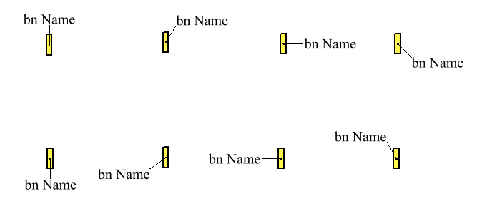
Figure 9-9 – Image of TextPoint used to place text at various bearings by placing the text at the end of an AugmentedRay (informative)
More details can be found in the documentation of the text package.

Surface Geometry
The text is drawn at a representative position within the surface. Only TextPoint elements are supported. How this position is obtained is controlled by the areaPlacement member of the TextPoint. The details are described in the documentation of the Text package.

Readable Text
The display engine may adjust text to be upright and readable on screen. TextPoint defaults to horizontal on the PortrayalCRS. Rotations beyond +/-90 degrees are to be avoided. Text rendered by TextLine is meant to be upright and readable at the reference point but may turn upside down when following a curve. The bearing of the curve at the reference point will be used by the portrayal engine to make the text readable and to maintain the relative placement of the text on the curve. See the following example diagrams.
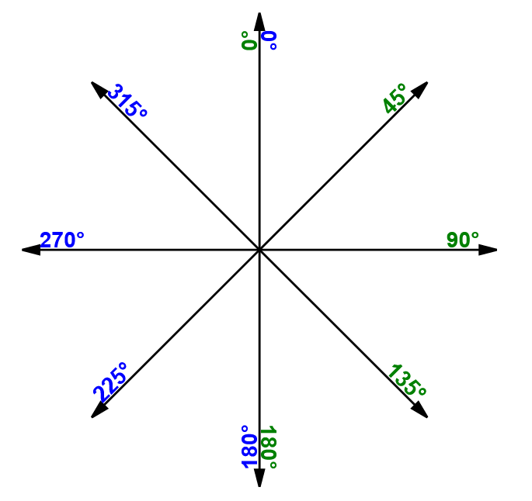
Figure 9-10 – Sample of TextLine on an augmented ray with placement at end of line. Green indicates no adjustment, blue indicates adjusted placement (informative)
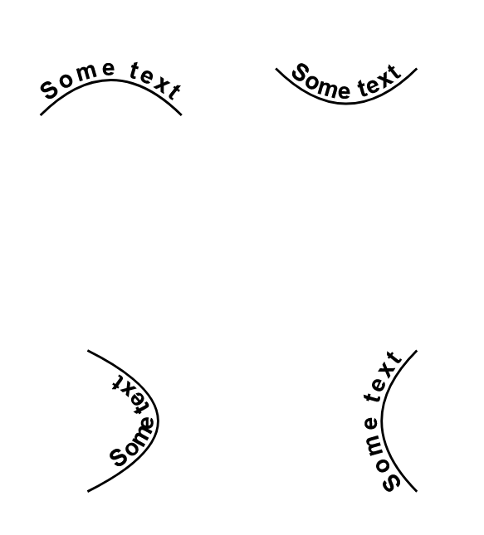
Figure 9-11 – Some text on curves (informative)

Course Up Display
If the display engine supports a course up or non-north up display then text placements and alignments may be adjusted automatically to keep the text readable.
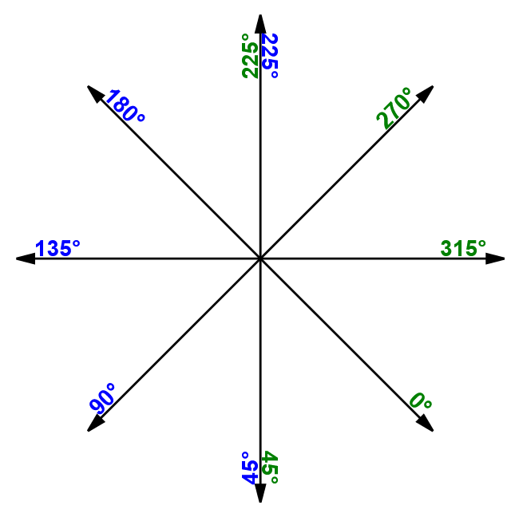
Figure 9-12 – TextLine when display is not north up (informative)
TextPoint placements in non-north up portrayals may also be adjusted in the display engine. The bearing and distance between the origin and the text reference point can be used to calculate the text alignment in order to retain the geographic placement and relative display distance.

Text Deconfliction
To avoid text overlaps and improve readability the display engine may suppress some text to make other text readable.

Coverage Instruction

Overview
An instruction to portray data coverages like gridded bathymetry, satellite images, etc.
“A coverage is a feature that has multiple values for each attribute type, where each direct position within the geometric representation of the feature has a single value for each attribute type.” [ISO 19123:2005, Introduction]
In this document coverage attributes used for portrayal are expected to have numeric values.
The assignment of Portrayal for a Coverage starts with a Coverage Feature. Like other Feature types a rule is used to match the Feature to Drawing instructions.
A first match lookup table is used to assign portrayal based on a specified coverage attribute. There are three options for coverage portrayal: filling with colour; annotating with numeric text; or annotating with symbols.

Discrete Coverages
Discrete coverages are portrayed by applying a symbol and/or numeric annotation to the direct position associated with each value of an attribute of the coverage.
Continuous Coverages
Continuous coverages are portrayed by filling the cells that have actual data associated, as opposed to no data (termed “fill values” in HDF5, not to be confused with colour or symbol fills as the terms are used in portrayal). The fills used in portrayal may be solid fills; patterns of symbols; pixmaps; or gradients. Fill transparency may also be specified by the applicable portrayal rule. Interpolation methods, if defined in the coverage type (see S-100 Part 8, clause 8-7.7.3) may be applied to depict variations in data values in each grid cell. The anchor point for text or symbol placement is dependent on the coverage’s spatial type and the placement attribute in the Portrayal Catalogue.
Irregular shape grids, ungeorectified grids, variable cell size grids (see S-100 Part 10, Table 10c-15) are all treated similarly to regular grids as far as portrayal is concerned. For variable cell size grids, unit cells must be used for symbol fills (that is, in an expanded cell that covers more than one unit cell, the symbol must be depicted at the centre of each unit cell included in the expanded cell).

Colour Assignment
Colours are applied to a coverage by using a lookup table that matches a selected attribute value and specifies a colour. For a continuous coverage such as grid cells, pixels or tiles then each element is processed and colour filled with the appropriate colour. For a discrete coverage with distinct points colour is applied as a Pen Down or dott operation using the assigned pen width.
A lookup table entry can match a range of values and assign a single colour to that range or specify a start and end colour that is used to create a gradient or ramp effect as a linear interpolation of the value range across the colour range.

Numeric and Symbol Annotations
For a continuous coverage the centre of each cell (for example rectangle, tile, triangle) is used as the anchor point of the text or symbol.
For discrete coverages, the anchor point for annotations is the direct position associated with each value of the attribute designated by the attributeCode parameter of the CoverageFill (see clause 9-12.7.4.1).
For numeric annotations, overplot removal or collision avoidance is expected. A buffer can be used to provide some space between the annotations. A buffer of 0 means that direct overplot is used when digits interact. An enumeration called ‘champion’ is used to specify which annotation to keep (largest or smallest value) when an interaction occurs. For numeric annotations the text shall be placed such that the optical/geometric centre of the text represents the location.
For symbol annotations separate attributes from the coverage can be used to apply a scaling and rotation to the symbol. This can be useful for example when portraying a coverage that carries wave height and direction.

Augmented Geometry

Overview
In case the required geometry for a drawing instruction is not explicitly given in a geographic dataset the portrayal function will generate this “augmented” geometry. A set of classes for such augmented geometries are part of the model. All positions used in this classes refer to a given coordinate reference system. Three types of CRS are supported:
- Geographic CRS
The coordinates are geographic coordinates.
- Portrayal CRS
The coordinate are referenced to the output device of the portrayal.
- Local CRS
The coordinates referring to a coordinate system with axes parallel to the Portrayal CRS but the origin shifted to the position of the referenced feature. Only point feature are supported for that type of CRS.
Note: The generated geometry only exists temporary for the purpose of portrayal and is not part of the dataset.
All types of augmented geometries can be used for the portrayal of text.
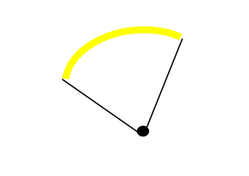
Figure 9-13 – Point Feature with Augmented geometries
More details can be found in the documentation of the drawing instruction model.

Model of the Drawing Instruction Package
This package contains classes which describe the output of the portrayal functions. Display instructions link the feature types and their geometry to elements from the Symbol Elements package. Figure 9-14 below shows the model.
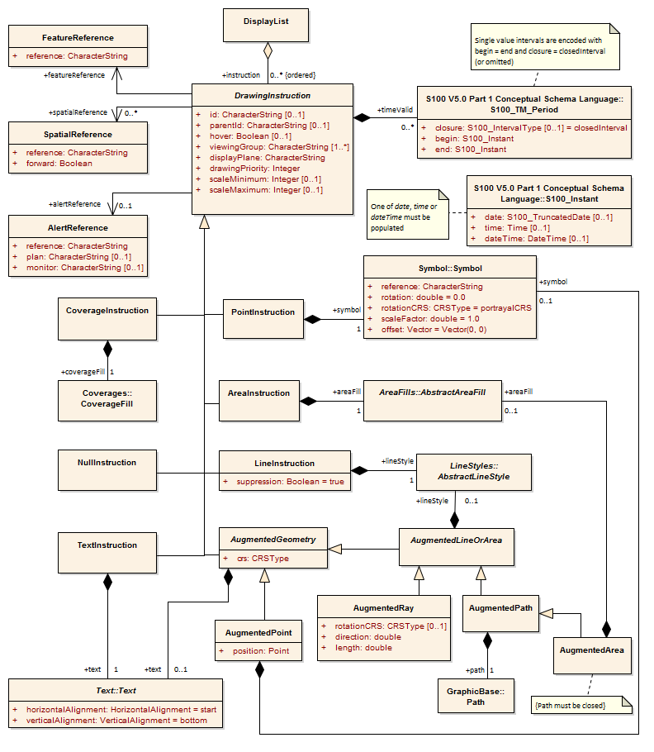
Figure 9-14 – Drawing Instructions

DisplayList
Role Name | Name | Description | Mult. | Type
Class | DisplayList | A ordered set of Drawing Instructions | - | -
Role | instruction | An instruction of this list | 0..* | DrawingInstruction

DrawingInstruction
Role Name | Name | Description | Mult. | Type
Class | DrawingInstruction | Abstract base class for all drawing instructions | - | -
Attribute | id | An identifier for the drawing instruction | 0..1 | string
Attribute | parentId | Instruction is dependent on parent drawing instruction(s). If no referenced instructions are executed during rendering then this instruction should not be executed.  Execution of referenced (parent) instructions can be affected by many aspects of the visualization process including viewing group settings, display plane visibility, line suppression, scale minimum/maximum, date dependency, hover status, and dependencies of the parent instruction | 0..1 | string
Attribute | hover | Specifies whether the instruction is shown only on hover-over.  OEM support for this feature is optional | 0..1 | boolean
Attribute | viewingGroup | The Viewing Group(s) the instruction is assigned to. Instruction is disabled if any Viewing Group is disabled | 1..* | string
Attribute | displayPlane | The display plane the instruction is assigned to | 1 | string
Attribute | drawingPriority | The priority that defines the order of drawing | 1 | integer
Attribute | scaleMinimum | Scale denominator to define the minimum scale for which the instruction will be shown. If not given there is no minimum scale | 0..1 | integer
Attribute | scaleMaximum | Scale denominator to define the maximum scale for which the instruction will be shown. If not given there is no maximum scale | 0..1 | integer
Role | featureReference | The reference to the feature type that will be depicted by the instruction | 1 | FeatureReference
Role | spatialReference | The reference(s) to the spatial type components of the feature that defines the geometry used for the depiction. Not used when the entire geometry of the feature should be depicted | 0..* | SpatialReference
Role | timeValid | The drawing instruction is valid during the specified time interval(s) | 0..* | S100_TM_Period
Role | alertReference | The reference to the alert in the Alert Catalogue that is triggered by the geometry of the instruction | 0..1 | AlertReference

FeatureReference
Role Name | Name | Description | Mult. | Type
Class | FeatureReference | A reference to a feature type | - | -
Attribute | reference | The identifier of the feature type | 1 | string

SpatialReference
Role Name | Name | Description | Mult. | Type
Class | SpatialReference | A reference to a spatial type | - | -
Attribute | reference | The identifier of the spatial type | 1 | string
Attribute | forward | If true the spatial object is used in the direction in which it is stored in the data. Only applies to curves | 1 | boolean

AlertReference
Role Name | Name | Description | Mult. | Type
Class | AlertReference | A reference to an alert in the Alert Catalogue | - | -
Attribute | reference | The identifier of the Alert Catalogue entry | 1 | string
Attribute | plan | The viewing group the alert highlight is assigned to when active in route planning | 0..1 | string
Attribute | monitor | The viewing group the alert highlight is assigned to when active in route monitoring | 0..1 | string

NullInstruction
Role Name | Name | Description | Mult. | Type
Class | NullInstruction | An instruction that indicates that no portrayal is required for the referenced feature | - | -

PointInstruction
Role Name | Name | Description | Mult. | Type
Class | PointInstruction | A drawing instruction for point symbol | - | -
Role | symbol | The symbol to be depicted | 1 | Symbol::Symbol

LineInstruction
Role Name | Name | Description | Mult. | Type
Class | LineInstruction | A drawing instruction for line geometry | - | -
Attribute | suppression | Whether another line instruction of higher priority can suppress the drawing of this line instruction | 1 | boolean = True
Role | lineStyle | The line style used for the depiction | 1 | LineStyles::AbstractLineStyle

AreaInstruction
Role Name | Name | Description | Mult. | Type
Class | AreaInstruction | A drawing instruction for area geometry | - | -
Role | areaFill | The area fill used for the depiction | 1 | AreaFills::AbstractAreaFill

TextInstruction
Role Name | Name | Description | Mult. | Type
Class | TextInstruction | A drawing instruction for depicting text | - | -
Role | text | The text to be depicted | 1 | Text::Text

CoverageInstruction
Role Name | Name | Description | Mult. | Type
Class | CoverageInstruction | A drawing instruction for depicting coverages of data | - | -
Role | coverageFill | The coverage fill used for depiction | 1 | Coverages::CoverageFill

AugmentedGeometry
Role Name | Name | Description | Mult. | Type
Class | AugmentedGeometry | A base class for drawing instructions that uses geometry not available in the dataset. The geometry is generated by the portrayal functions according to a defined CRS | - | -
Attribute | crs | The coordinate reference system of the generated geometry. One of  - Geographic CRS  - Portrayal CRS  - Local CRS  For detailed description see the documentation of the GraphicsBase package | 1 | GraphicBase::CRSType
Role | text | A text to be depicted by the instruction. The rules for text apply depending on the type of geometry used by the instruction | 0..1 | Text::Text

AugmentedPoint
Role Name | Name | Description | Mult. | Type
Class | AugmentedPoint | A drawing instruction for a point symbol where the position is not given by the feature type | - | -
Attribute | position | The position of the symbol | 1 | GraphicBase::Point
Role | symbol | The symbol to be depicted | 0..1 | Symbol::Symbol

AugmentedLineOrArea
Role Name | Name | Description | Mult. | Type
Class | AugmentedLineOrArea | A base class for linear augmented geometry | - | -
Role | lineStyle | The line style to be depicted | 0..1 | LineStyles::LineStyle

AugmentedRay
Role Name | Name | Description | Mult. | Type
Class | AugmentedRay | A drawing instruction that defines a line from the position of a point feature to another position. The position is defined by the direction and the length attributes. It can be used for drawing line styles or line texts | - | -
Attribute | rotationCRS | If present, specifies the CRS for direction | 0..1 | GraphicsBase::CRSType
Attribute | direction | The direction of the ray relative to the used CRS | 1 | double
Attribute | length | The length of the ray. The units depending on the used CRS | 1 | double

AugmentedPath
Role Name | Name | Description | Mult. | Type
Class | AugmentedPath | A drawing instruction for a line. It can be used for drawing line styles or line texts | - | -
Role | path | The path defining the line geometry | 1 | GraphicsBase::Path

AugmentedArea
Role Name | Name | Description | Mult. | Type
Class | AugmentedArea | A drawing instruction for an area. It can be used for drawing line styles, area fills, or area texts. The used path must be closed | - | -
Role | areaFill | The area fill to be depicted | 0..1 | AreaFills::AreaFill

Symbol Definitions

Overview
The SymbolDefinition package describes the graphic primitives used for the portrayal. Parts of the primitives are defined externally by using SVG definitions. Those external parts will be referenced from the types in this model. The package diagram is shown in the Figure 9-15 below.
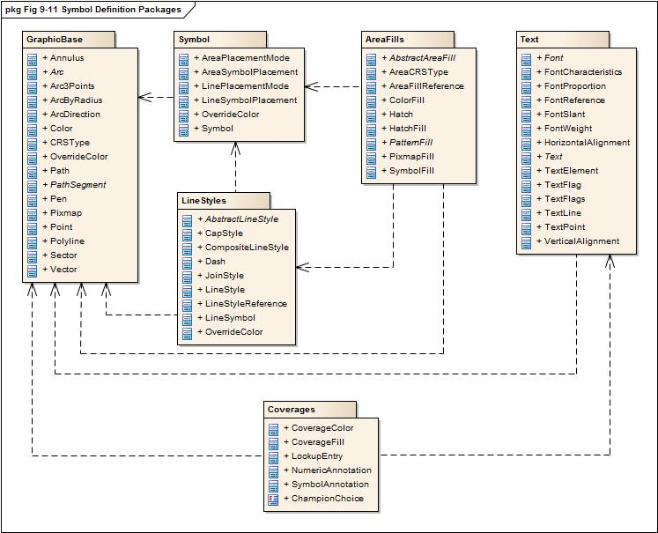
Figure 9-15 – Symbol Definition Packages

The GraphicBase package

Overview
This package contains graphic base types for the use in other packages.

Model
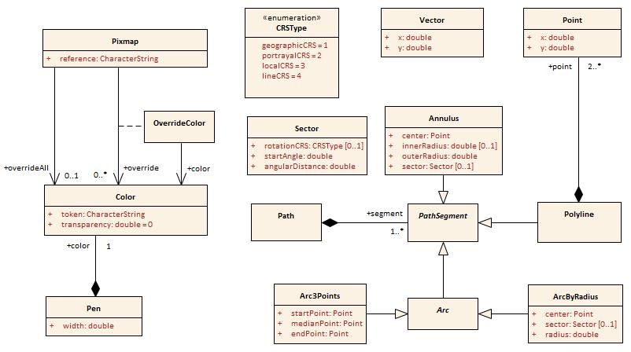
Figure 9-16 – Graphics Base

Point
Role Name | Name | Description | Mult. | Type
Class | Point | A zero-dimensional geometric object in a two-dimensional coordinate space. The coordinate will refer to a coordinate reference system | - | -
Attribute | x | The x-coordinate of the point. In case the CRS is a geographic CRS this refers to the longitude | 1 | double
Attribute | y | The y-coordinate of the point. In case the CRS is a geographic CRS this refers to the latitude | 1 | double

Vector
Role Name | Name | Description | Mult. | Type
Class | Vector | A geometric object that has both a magnitude and a direction. It is limited to Cartesian coordinate reference systems | - | -
Attribute | x | The x-coordinate of the vector | 1 | double
Attribute | y | The y-coordinate of the vector | 1 | double

Color
Role Name | Name | Description | Mult. | Type
Class | Color | Representing a colour according to the colour model | - | -
Attribute | token | The token specifies either an element in a colour table or a colour definition in the RGB space | 1 | string
Attribute | transparency | The value specifies the transparency; between 0 (opaque) and 1 (full transparent) | 1 | double

Pen
Role Name | Name | Description | Mult. | Type
Class | Pen | A tool for drawing lines | - | -
Attribute | width | The width of the pen in mm | 1 | double
Role | color | The colour of the pen comprises the actual colour and the transparency | 1 | Color

Pixmap
Role Name | Name | Description | Mult. | Type
Class | Pixmap | A two dimensional array of pixels defining an image | - | -
Attribute | reference | A reference to an external definition of the pixmap. This string is a unique identifier within the pixmap section of the Portrayal Catalogue | 1 | string
Role | overrideAll | A colour that override all none fully transparent colours used within the pixmap | 0..1 | Color
Association | override | A colour to be replaced by another colour | 0..* | OverrideColor

OverrideColor
Role Name | Name | Description | Mult. | Type
Class | OverrideColor | Association class for the replacement of an existing colour in the pixmap with another colour | - | -
Role | color | The colour that is used to replace the existing colour in the pixmap | 1 | Color

CRSType
Role Name | Name | Description
Type | CRSType | The value describes the type of a CRS. This includes the axes definitions, base line for angle measurement and units for distances
Enumeration | geographicCRS | A geographic CRS with axis latitude and longitude measured in degrees. Angles are defined clockwise from the true north direction. Distances will be measured in metres
Enumeration | portrayalCRS | A Cartesian coordinate system with the y-axis pointing upwards. Units on the axes and for distances are millimetres. Angles are measured in degrees clockwise from the positive y-axis.  Note that the actual output device may have a different orientation of the y-axis
Enumeration | localCRS | A Cartesian coordinate system originated at a local geometry. Units on the axes and for distances are millimetres. Angles are measured in degrees clockwise from the positive y-axis.  See explanations for details
Enumeration | lineCRS | A none-Cartesian coordinate system where the x-axis is following the geometry of a curve and the y-axis is perpendicular to the x-axis (positive to the left of the x-axis).  Units on the axes and for distances are millimetres. Angles are measured in degrees clockwise from the positive y-axis

Figure 9-17 below shows how the local CRS are defined for the different types of geometry.
From left to right:
- Local CRS for point geometry
Note: for multi points the local CRS is repeated at each point.
- Local CRS for curve geometry. The origin of the coordinate system can be any point of the line. This point can be defined by the absolute or relative distance from the start of the line. The x-axis is directed in the direction of the tangent at the tangency point and the y-axis is oriented perpendicular to this direction.
- Local CRS for surface geometry. For the boundary the same rules apply as for curve geometry. For the interior of the surface a coordinate system is used that has axes parallel to the Portrayal CRS. The origin can be an arbitrary point that is constant relative to the surface. This point can be outside the surface.
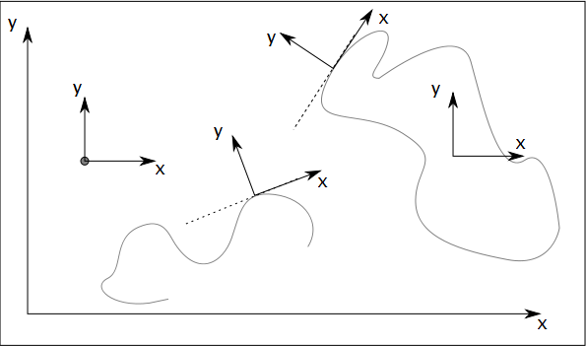
Figure 9-17 – Local CRS
X
Y
Y

Figure 9-18 – Line CRS

Sector
Role Name | Name | Description | Mult. | Type
Class | Sector | Region of the Cartesian plane enclosed by two radii | - | -
Attribute | rotationCRS | If present, specifies the CRS for startAngle | 0..1 | CRSType
Attribute | startAngle | The direction of the radius that defines the beginning of the sector | 1 | double
Attribute | angularDistance | The angular distance of the sector measured in degrees. Positive values means clockwise, negative values means anti-clockwise | 1 | double

Path
Role Name | Name | Description | Mult. | Type
Class | Path | The definition of linear geometry by a composition of segments | - | -
Role | segment | The segments that build up the path | 1..* | PathSegment

Paths can be closed or not closed. A closed path has coinciding start and end points. Segments are connected until a path is closed. In that case the next segment is not connected and the path contains multiple sub-paths.

PathSegment
Role Name | Name | Description | Mult. | Type
Class | PathSegment | Abstract base class for all segments that can be used within a path | - | -

Polyline
Role Name | Name | Description | Mult. | Type
Class | Polyline | A segment defining its geometry by a series of points | - | -
Role | point | The segments the build up the path | 2..* | Point

Arc
Role Name | Name | Description | Mult. | Type
Class | Arc | Abstract base class for segments describing arcs of a circle | - | -

Arc3Points
Role Name | Name | Description | Mult. | Type
Class | Arc3Points | A segment describing an arc of a circle that is defined by 3 points. The points must not be colinear | - | -
Attribute | startPoint | The point where the arc starts | 1 | Point
Attribute | medianPoint | An arbitrary point on the arc | 1 | Point
Attribute | endPoint | The point where the arc ends | 1 | Point

ArcByRadius
Role Name | Name | Description | Mult. | Type
Class | ArcByRadius | A segment describing an arc of a circle that is defined by the centre of the arc and a radius. Optional the arc can be restricted by a sector | - | -
Attribute | center | The centre of the arc | 1 | Point
Attribute | sector | The sector defining where the arc starts and end. If not present the arc is a full circle | 0..1 | Sector
Attribute | radius | The radius of the circle | 1 | double

Annulus
Role Name | Name | Description | Mult. | Type
Class | Annulus | A ring-shaped region bounded by two concentric circles. Optionally it can be enclosed by two radii of the circle | - | -
Attribute | center | The centre of the arc | 1 | Point
Attribute | innerRadius | The radius of the smaller circle. If not present the segment describes a sector of a circle | 0..1 | double
Attribute | outerRadius | The radius of the larger circle | 1 | double
Attribute | sector | The sector of an annulus segment | 0..1 | Sector

The Symbol package

Model
This package contains the model of a symbol. Note that the definition of the symbol graphic itself is not the subject of this model. This will be defined in external files according to the SVG 1.1 recommendation.
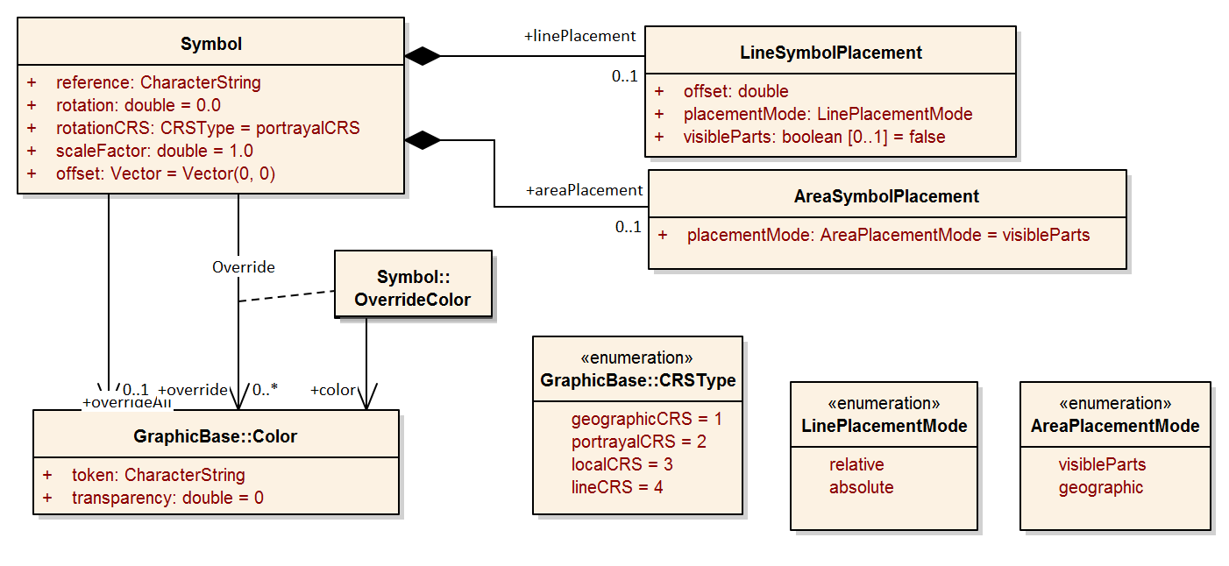
Figure 9-19 – Symbol Package

Symbol
Role Name | Name | Description | Mult. | Type
Class | Symbol | A two dimensional graphical element | - | -
Attribute | reference | A reference to an external definition of the symbol graphic. This is an unique identifier in the symbol section of the Portrayal Catalogue | 1 | string
Attribute | rotation | The rotation angle of the symbol. The default value is 0 | 1 | double
Attribute | rotationCRS | Specifies the coordinate reference system for the rotation | 1 | GraphicsBase::CRSType
Attribute | scaleFactor | The factor by which the original symbol graphic is scaled. The default value is 1 | 1 | double
Attribute | offset | The shift of the symbols position from the position of the geometry. The default value is the vector with length equals to 0 | 1 | GraphicsBase::Vector
Role | overrideAll | A colour that override all none fully transparent colours used within the symbol | 0..1 | GraphicsBase::Color
Association | override | A colour to be replaced by another colour | 0..* | OverrideColor
Role | linePlacement | Information where on a line the symbol should be placed | 0..1 | LineSymbolPlacement
Role | areaPlacement | Defines the placement of a symbol within an area | 0..1 | AreaSymbolPlacement

OverrideColor
Role Name | Name | Description | Mult. | Type
Class | OverrideColor | Association class for the replacement of an existing colour in the symbol | - | -
Role | color | The colour that is used to replace an existing colour in the symbol | 1 | Color

LineSymbolPlacement
Role Name | Name | Description | Mult. | Type
Class | LineSymbolPlacement | Defines the placement of a symbol along a line | - | -
Attribute | offset | The offset from the start of the curve | 1 | double
Attribute | placementMode | The mode that defines how the offset is to be interpreted | 1 | LinePlacementMode
Attribute | visibleParts | When true, indicates the placement applies to each visible part of the curve. Default = false | 0..1 | boolean

AreaSymbolPlacement
Role Name | Name | Description | Mult. | Type
Class | AreaSymbolPlacement | Defines the placement of a symbol within an area | - | -
Attribute | placementMode | The mode that defines how the symbol has to placed. | 1 | AreaPlacementMode

LinePlacementMode
Role Name | Name | Description
Type | LinePlacementMode | Defines the type of placement of a symbol along a line
Enumeration | relative | The offset has to be interpreted as homogenous coordinates, 0 for the start and 1 for the end of the curve
Enumeration | absolute | The offset is the distance from the start of the curve

AreaPlacementMode
Role Name | Name | Description
Type | AreaPlacementMode | Defines the type of placement of a symbol within an area
Enumeration | visibleParts | The symbol has to be placed at a representative position in each visible part of the surface
Enumeration | geographic | The symbol has to be placed at a representative position of the geographic object

The LineStyles package

Model
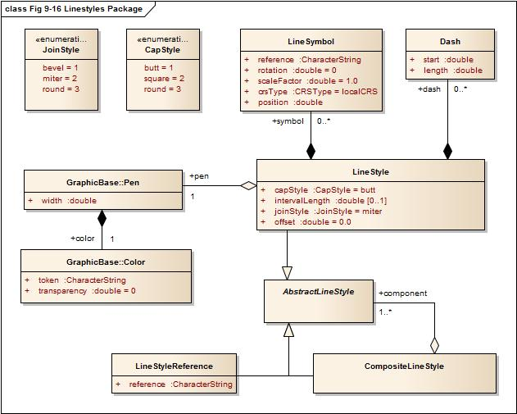
Figure 9-20 – Line Styles Package

AbstractLineStyle
Role Name | Name | Description | Mult. | Type
Class | AbstractLineStyle | Abstract base class for graphics to depict line geometry | - | -

LineStyle
Role Name | Name | Description | Mult. | Type
Class | LineStyle | A style for line geometry | - | -
Attribute | offset | An offset perpendicular to the direction of the line. The value refers to the y-axis of the line CRS (positive to the left, mm) | 1 | double
Attribute | capStyle | The decoration that is applied where a line segment ends | 1 | CapStyle
Attribute | joinStyle | The decoration that is applied where two line segments meet | 1 | JoinStyle
Attribute | intervalLength | The length of a repeating interval of the line style along the x-axis of the line CRS (units in mm) If not defined, the line style describes a solid line and/or a line represented by symbols | 0..1 | double
Role | dash | The dashes of a dashed line style . If not defined the line style describes a line represented only by symbols; the pen is not used | 0..* | Dash
Role | pen | The pen used for drawing the line | 1 | Pen
Role | symbol | Symbols placed along the line | 0..* | LineSymbol

Dash
Role Name | Name | Description | Mult. | Type
Class | Dash | A single dash in a repeating line pattern | - | -
Attribute | start | The start of the dash measured from the start of the repeating interval,along the x-axis of the line CRS (units in mm) | 1 | double
Attribute | length | The length of the dash along the x-axis of the line CRS (units in mm) | 1 | double

LineSymbol
Role Name | Name | Description | Mult. | Type
Class | LineSymbol | A symbol placed along a line in a repeating pattern | - | -
Attribute | reference | A reference to an external definition of the symbol graphic. This refers to an identifier of a Catalogue item | 1 | string
Attribute | rotation | The rotation angle of the symbol. The default value is 0 | 1 | double
Attribute | scaleFactor | The scale factor of the symbol. The default is 1.0 | 1 | double
Attribute | crsType | The type of the CRS where the symbol has to be transformed to. Possible values are localCRS, lineCRS and portrayalCRS | 1 | CRSType
Attribute | position | The position of the symbol measured from the start of the repeating interval,along the x-axis of the line CRS (units in mm) | 1 | double

CompositeLineStyle
Role Name | Name | Description | Mult. | Type
Class | CompositeLineStyle | A line style made with an aggregation of other line styles
Role | component | The components of the composite line style | 1..* | AbstractLineStyle

LineStyleReference
Role Name | Name | Description | Mult. | Type
Class | LineStyleReference | A line style defined in an external file
Attribute | reference | The reference to the external definition of the line style. This is an unique identifier in the line style section of the Portrayal Catalogue | 1 | string

JoinStyle
Role Name | Name | Description
Type | JoinStyle | The decoration that is applied where two line segments meet
Enumeration | bevel
Enumeration | miter
Enumeration | round

CapStyle
Role Name | Name | Description
Type | CapStyle | The decoration that is applied where a line segment ends.
Enumeration | butt
Enumeration | square
Enumeration | round

The AreaFills package

Model
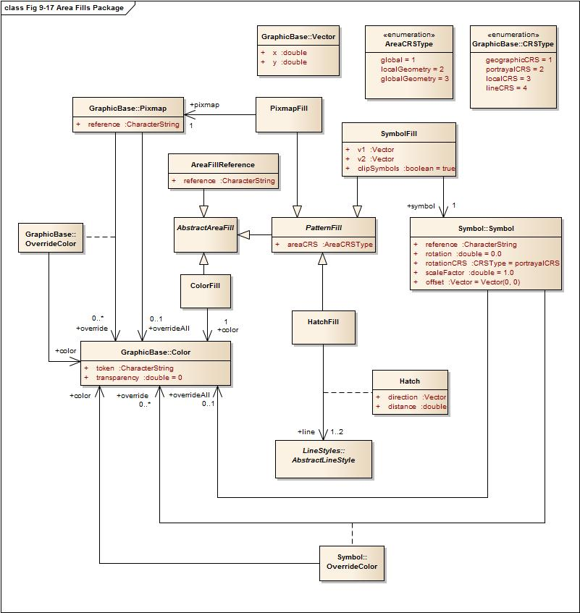
Figure 9-21 – Area Fills Package

AbstractAreaFill
Role Name | Name | Description | Mult. | Type
Class | AbstractAreaFill | Abstract base class for graphics that are designed to fill an area | - | -

PatternFill
Role Name | Name | Description | Mult. | Type
Class | PatternFill | Abstract base class for pattern area fills | - | -
Attribute | areaCRS | Coordinate reference system which defines the origin of the pattern | 1 | AreaCRSType

AreaFillReference
Role Name | Name | Description | Mult. | Type
Class | AreaFillReference | An area fill defined in an external file | - | -
Attribute | reference | The reference to the external definition. This is an unique identifier in the area fill section of the Portrayal Catalogue | 1 | string

ColorFill
Role Name | Name | Description | Mult. | Type
Class | ColorFill | Class defining a solid colour fill for an area | - | -
Role | color | References the colour and transparency for the colour fill | 1 | Color

PixmapFill
Role Name | Name | Description | Mult. | Type
Class | PixmapFill | Pattern fill where the pattern is defined by a pixmap | - | -
Role | pixmap | The pixmap defining the pattern | 1 | Pixmap

SymbolFill
Role Name | Name | Description | Mult. | Type
Class | SymbolFill | Pattern fill where the pattern is defined by repeated symbols | - | -
Role | symbol | The symbol used for the pattern | 1 | Symbol
Attribute | v1 | Defines the offset of the next symbol in the first dimension of the pattern according to the local CRS | 1 | Vector
Attribute | v2 | Defines the offset of the next symbol in the second dimension of the pattern according to the local CRS | 1 | Vector
Attribute | clipSymbols | Indicates whether the symbols in the pattern are to be clipped by the area (when they are part in/out of the area) or whether the symbol is not drawn at all unless it is completely contained in the area | 1 | boolean  True: Fill symbols are clipped at area boundaries  False: Fill symbols extending over the area boundaries are not drawn at all

HatchFill
Role Name | Name | Description | Mult. | Type
Class | HatchFill | Defining a pattern made of one or two sets of parallel lines | - | -
Association | hatch | A set of parallel lines | 1 | Hatch

Hatch
Role Name | Name | Description | Mult. | Type
Class | Hatch | A set of parallel lines used for an area fill pattern
Attribute | direction | The vector defining the direction of the set of lines | 1 | Vector
Attribute | distance | The distance between the lines measured perpendicular to the direction | 1 | double
Role | line | The line style used for each hatch line | 1..2 | LineStyles:: AbstractLineStyle

AreaCRSType
Role Name | Name | Description
Type | PatternCRS | Describes how a fill patter is referenced
Enumeration | global | Anchor point is consistent with a location on the drawing device for, example starting with the corner of the screen. As screen pans the pattern will appear to shift/move through the object on screen
Enumeration | localGeometry | Anchor point is consistent with the local geometry of the object being depicted, for example the upper left corner of the object. Patterns of adjacent objects may not match
Enumeration | globalGeometry | The anchor point of the fill pattern is defined at a common location such that patterns remain consistent relative to all area objects

The Text package

Overview
The text package contains the types necessary for the depiction of text. This includes fonts. In this model fonts may be described by characteristics or referenced by name. Two types of text instructions are supported:
- Text relative to a point
- Text that will be drawn along a linear geometry

Fonts
A font is a set of typefaces. A typeface is the artistic representation or interpretation of characters; it is the way the type looks.
This standard supports two methods of defining fonts, the first describes a font by four attributes and let the system find a best match to an actual font available on the graphic system. The second method is referencing an external font file. The format of this file must conform to the ‘True Type Font’ standard and must be included in the the Portrayal Catalogue.

Model
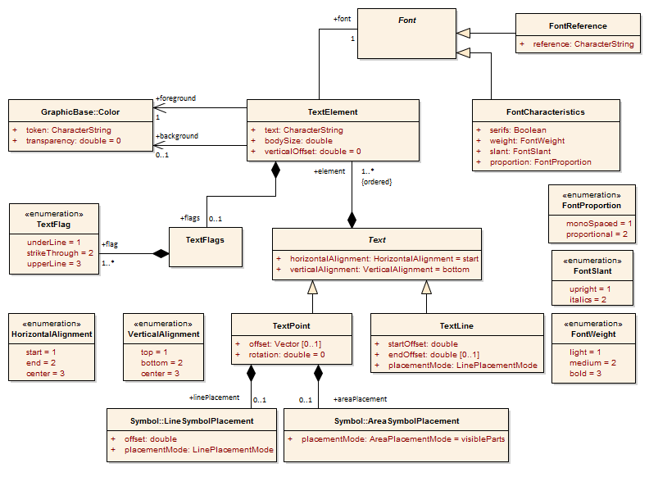
Figure 9-22 – Text Package

Font
Role Name | Name | Description | Mult. | Type
Class | Font | Abstract base class for fonts | - | -

FontCharacteristics
Role Name | Name | Description | Mult. | Type
Class | FontCharacteristics | Class describing the main characteristics of a font | - | -
Attribute | serifs | Describes whether the typefaces contain serifs or not | 1 | boolean
Attribute | weight | Describes the thickness of the typefaces | 1 | FontWeight
Attribute | slant | Describes the slant of the typefaces | 1 | FontSlant
Attribute | proportion | Describes whether all typefaces in the font have an individual width or a fixed width | 1 | FontProportion

FontReference
Role Name | Name | Description | Mult. | Type
Class | FontReference | Class referencing a font from an external source | - | -
Attribute | reference | The identifier for the external file within the Portrayal Catalogue | 1 | string

Text
Role Name | Name | Description | Mult. | Type
Class | Text | The abstract base class of graphic elements for depicting text. The text is composed of elements | - | -
Attribute | horizontalAlignment | Specifies how the text is horizontally aligned relative to the anchor point. Default = start | 1 | HorizontalAlignment
Attribute | verticalAlignment | Specifies how the text is vertically aligned relative to the anchor point. Default = bottom | 1 | VerticalAlignment
Role | element | The ordered list of text elements | 1..* | TextElement

TextPoint
Role Name | Name | Description | Mult. | Type
Class | TextPoint | A graphic element for depicting text relative to a point | - | -
Attribute | offset | Specifies the offset from the anchor point with respect to the portrayal CRS | 0..1 | GraphicsBase::Vector
Attribute | rotation | Specifies the rotation angle relative to the portrayal CRS. Default = 0 | 1 | double
Role | linePlacement | Describes the placement of the text when the geometry is a curve | 0..1 | Symbol::  LineSymbolPlacement
Role | areaPlacement | Describes the placement of the text when the geometry is a surface | 0..1 | Symbol::  AreaSymbolPlacement

TextLine
Role Name | Name | Description | Mult. | Type
Class | TextLine | A graphic element for depicting text along linear geometry | - | -
Attribute | startOffset | This offset specifies the anchor point on the line | 1 | double
Attribute | endOffset | This offset specifies the stop point of the text at the line. If present the startOffset does not specifies an anchor point but the start point of the text. The text will evenly be spaced between the two positions. Horizontal alignment has no effect in this case | 0..1 | double
Attribute | placementMode | Specifies how the offsets have to be interpreted | 1 | Symbol::  LinePlacementMode

TextFlags
Role Name | Name | Description | Mult. | Type
Class | TextFlags | A container for text flags | - | -
Role | flag | A text flag | 1..* | TextFlag

TextElement
Role Name | Name | Description | Mult. | Type
Class | TextElement | A sub element of a graphic text | - | -
Attribute | text | The text to be depicted | 1 | string
Attribute | bodySize | This property describes the size with which the text will be depicted | 1 | double
Attribute | verticalOffset | The vertical offset in mm between the base line of the text element and the base line of the text. This can be used to generate sub- or superscripts. Default = 0 | 1 | double
Role | flags | Flags describe special properties of the text element like underline etc. | 0..1 | TextFlags
Role | font | The font used for the depiction of the text element. | 1 | Font
Role | foreground | The colour used to depict the glyphs | 1 | Color
Role | background | The colour to fill the rectangle surrounding the text element before the text is depicted. If not given there is no fill (transparent) | 0..1 | Color

FontSlant
Role Name | Name | Description
Type | FontSlant | The slant used within a font
Enumeration | upright | Typefaces are upright
Enumeration | italics | Typefaces are cursive

FontWeight
Role Name | Name | Description
Type | FontWeigth | The thickness used for the typefaces in a font
Enumeration | light | Typefaces are depicted as thin (standard)
Enumeration | medium | Typefaces are depicted thicker as ‘Light’ but not as thin as ‘Bold’
Enumeration | bold | Typefaces are depicted more prominent (Bold)

FontProportion
Role Name | Name | Description
Type | FontProportion | The values describe how the width of the typefaces in a font is defined
Enumeration | monoSpaces | All typefaces in a font have the same width, also known as ‘typewriter’ fonts
Enumeration | proportional | Any typeface in the font as its individual width

TextFlag
Role Name | Name | Description
Type | TextFlag | The values describe some effects used when the text will be depicted. The values can be combined
Enumeration | underLine | Text is depicted with a line under the text
Enumeration | strikeThrough | Text is depicted struck through, a line goes through the text
Enumeration | upperLine | Text is depicted with a line above the text

VerticalAlignment
Role Name | Name | Description
Type | VerticalAlignment | Describes the text placement relative to the anchor point in vertical direction
Enumeration | top | The anchor point is at the top of the text
Enumeration | bottom | The anchor point is at the bottom of the text
Enumeration | center | The anchor point is at the (vertical) centre of the text

HorizontalAlignment
Role Name | Name | Description
Type | HorizontalAlignment | Describes the text placement relative to the anchor point in horizontal direction
Enumeration | start | The anchor point is at the start of the text
Enumeration | end | The anchor point is at the end of the text
Enumeration | center | The anchor point is at the (horizontal) centre of the text

The Coverage package

Overview
The coverage package contains the types for the depiction of a Coverage. This portrayal is applicable to the portrayal of numeric Coverage values. Three types of coverage portrayals are supported:
- Colour;
- Numeric Annotation; and
- Symbol Annotation.

Ranges
Ranges are used to control how portrayal is assigned to the values in a Coverage. These make use of the S-100_NumericRange complex type which is defined in S-100 Part 1 Conceptual Schema Language. The Numeric Range type allows for various range definitions with different closure options.

Lookup Table
The CoverageFill class carries an ordered list of lookup entries. Each of these entries carries a range used to evaluate a match by testing if the coverage value matches the range. The first lookup entry with a matching range is used to apply up to one of each type of portrayal (colour, numeric annotation or a symbol) to the coverage element. This allows for example to fill a cell in a grid with a colour and assign a numeric or symbol annotation to the cell as well.
The lookup table can also associate an alert specified in the drawing instruction with a range of coverage values. When associating alerts with coverage values there may or may not be portrayal elements (colour, numeric annotation or a symbol) present.

Model
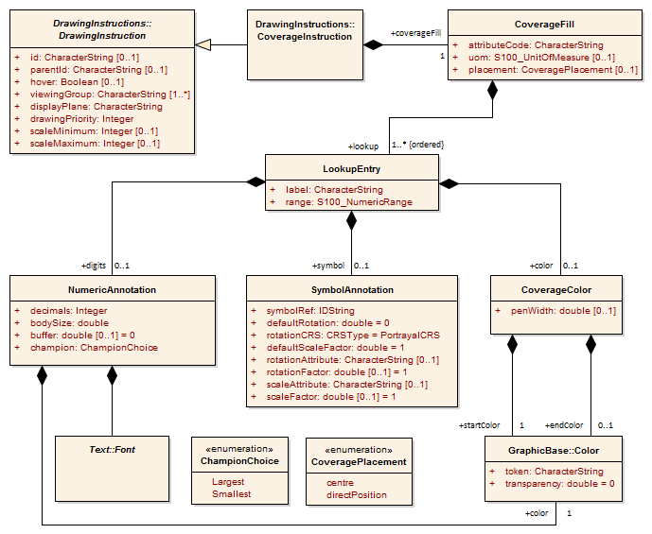
Figure 9-23 – Coverage Package

CoverageFill
Role Name | Name | Description | Mult. | Type
Class | CoverageFill | A class to fill a Coverage with using a lookup table to match a value or range of values and assign colour, numeric or symbol annotations | - | -
Attribute | attributeCode | Code of coverage attribute value to match | 1 | CharacterString
Attribute | uom | Unit of measure. If not given the values in the range are assumed to be same units as the coverage attribute values | 0..1 | S100_UnitOfMeasure
Attribute | placement | Designation of anchor point for placement of text or symbol annotation  Mandatory if and only if portrayal requires text or symbol annotation; otherwise omitted  This attribute is valid only for continuous coverages (for discrete coverages, the anchor point is the direct position). See clause 9-12.7.4.7 | 0..1 | CoveragePlacement
Role | lookup | Lookup table. The entries are ordered and processed on a first match basis | 1..* | LookupEntry

LookupEntry
Role Name | Name | Description | Mult. | Type
Class | LookupEntry | An entry in a lookup table used to assign portrayal to coverage elements. | - | -
Attribute | label | String used as a display label or legend field. | 1 | CharacterString
Attribute | range | Value range definition. Can be a single value, open or closed range etc. See S-100 Part 1 Conceptual Schema Language for details. | 1 | S100_NumericRange
Role | color | The colour to assign to the matching range. Can be a single colour or a colour ramp. | 0..1 | CoverageColor
Role | digits | Display the value as numeric digits. | 0..1 | NumericAnnotation
Role | symbol | Display a symbol. | 0..1 | SymbolAnnotation

CoverageColor
Role Name | Name | Description | Mult. | Type
Class | CoverageColor | A class to fill a Coverage with colour | - | -
Attribute | penWidth | Optional pen width to apply for dot colour used for discrete points | 0..1 | double
Role | startColor | The colour to assign to the matching range or to use as the start point in a colour ramp when ‘endColor’ is defined | 1 | GraphicBase::Color
Role | endColor | The colour to use as stop point in a colour ramp. The range of values is spread linearly across the range of colours from ‘startColor’ to ‘endColor’ to produce a gradient effect  The start and end colours shall be converted to the CIE xyL colour space and each component (that is x, y, L and transparancy) shall be interpolated individually before converting back to sRGB for display | 0..1 | GraphicBase::Color

NumericAnnotation
Role Name | Name | Description | Mult. | Type
Class | NumericAnnotation | A class for numeric textual annotations of values in a Coverage | - | -
Attribute | decimals | Number of decimal digits to show in subscript | 1 | integer
Attribute | bodySize | This property describes the size with which the text will be depicted | 1 | double
Attribute | buffer | Buffer to apply for collision detection in presentation units. Default=0 | 1 | double
Attribute | champion | Enumeration to indicate which value to display in the event of a collision | 1 | ChampionChoice
Role | font | Font information to use for display of numeric values across a coverage. Text::Font is a choice of either FontCharacteristics or FontReference | 1 | Text::Font
Role | color | Colour to draw the numeric annotation | 1 | GraphicBase::Color

SymbolAnnotation
Role Name | Name | Description | Mult. | Type
Class | SymbolAnnotation | A class for symbol annotations of values in a coverage. | - | -
Attribute | symbolRef | Reference to the symbol to apply. Catalogue id. | 1 | IDString
Attribute | defaultRotation | A default symbol rotation. Applies when rotation attribute not defined. Default=0 | 0..1 | double
Attribute | rotationCRS | Specifies the coordinate reference system for the rotation. Default=PortrayalCRS | 1 | GraphicsBase::CRSType
Attribute | defaultScale | A default symbol scale factor. Applies when scale attribute not defined. Default=1 | 1 | double
Attribute | rotationAttribute | The attribute code of the Coverage Attribute to use for the symbol rotation value. | 0..1 | CharacterString
Attribute | rotationFactor | Used to adjust the ‘rotationAttribute’ value by multiplication before applying. Default 1.0 | 0..1 | double
Attribute | scaleAttribute | The attribute code of the Coverage attribute to use for scaling the symbol size. | 0..1 | CharacterString
Attribute | scaleFactor | Used to adjust the ‘ scaleAttribute’ value by multiplication before applying. Default 1.0 | 0..1 | double

CoveragePlacement
Role Name | Name | Description
Type | CoveragePlacement | Defines the type of placement of a symbol or text annotations for a coverage
Enumeration | centre | The anchor point for annotations is the centre of the cell
Enumeration | directPosition | The anchor point for annotations is the direct position associated with each value of the attribute designated by the attributeCode parameter of the CoverageFill in which the placement is encoded

Coverages and placement
Table 9-2 – Coverages and placement
Coverage spatial type (attribute dataCodingFormat). See clause 10c-10.1 Data coding format | Interpolation (attribute interpolationType). See clause 8-7.7.3 S100_CV_InterpolationMethod | placement See clauses 9-12.7.4.1 CoverageFill and 9-12.7.4.6 CoveragePlacement | Resulting symbol/text placement
fixedStations  movingPlatform  stationwiseFixed  Feature oriented Regular Grid  (DCF 1, 4, 8, 9) | (not allowed) | (Not used. Ignore if encoded) | each direct position
regularGrid  ungeorectifiedGrid  irregularGrid  (DCF 2, 3, 5) | discrete | directPosition  OR  (not present) | each direct position
 | discrete | centre | ERROR - ignore placement attribute and portray at each direct position
 | (other) | directPosition | each direct position
 | (other) | centre  OR  (not present) | centre of each cell
variableCellSize  (DCF 6) | discrete | directPosition  OR  (not present) | each direct position for each unit grid cell
variableCellSize  (DCF 6) | discrete | centre | ERROR - ignore placement attribute and portray at each direct position
variableCellSize  (DCF 6) | (other) | directPosition | each direct position for each unit grid cell
variableCellSize  (DCF 6) | (other) | centre  OR  (not present) | centre of each unit grid cell
TIN  (DCF 7) | discrete | directPosition  OR  (not present) | each direct position (triangle vertex)
TIN  (DCF 7) | discrete | centre | ERROR - ignore placement attribute and portray at each direct position (triangle vertex)
TIN  (DCF 7) | (other) | directPosition | each direct position (triangle vertex)
TIN  (DCF 7) | (other) | centre  OR  (not present) | barycentre (centroid) of each triangle

The portrayal library

Overview
- Machine readable.
- A file/directory structure with a Catalogue file.
- Files for pixmaps, symbols, complex line styles, areafills, fonts and colour profiles.
- Alert information in a separate file.
- Portrayal rules in separate files.
- Model and Schema for the Catalogue included.

Structure
Root ---- (contains the Catalogue named “portrayal_catalogue.xml”, and optionally an Alert Catalogue file)
|
|-- Pixmaps (contains XML files describing pixmaps)
|
|-- ColorProfiles (contains XML files with colour profiles)
|
|-- Symbols (contains SVG files with symbols and CSS2 style sheets)
|
|-- LineStyles (contains XML files with line styles)
|
|-- AreaFills (contains XML files area fills)
|
|-- Fonts (contains TrueType font files)
|
|-- Rules (contains files with rules which map features to drawing instructions)

Model of the Catalogue
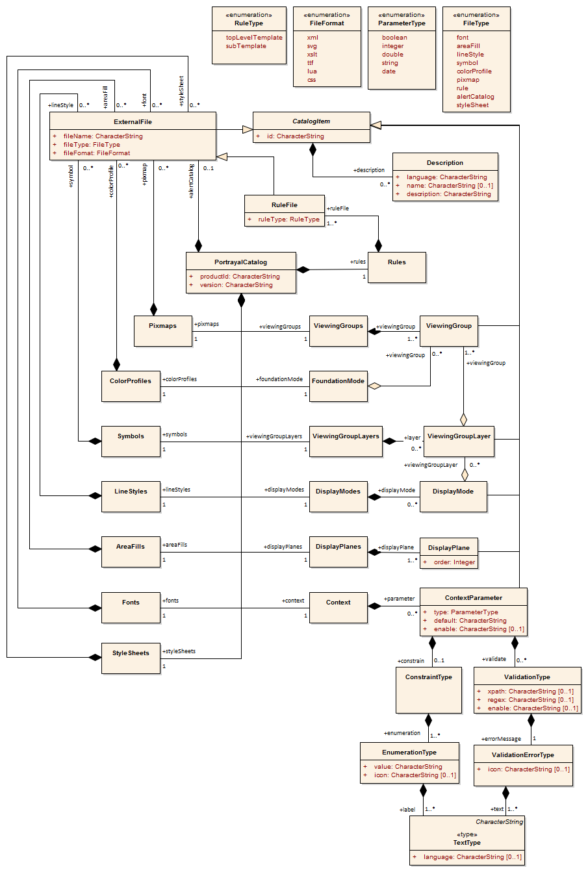
Figure 9-24 – Catalogue

PortrayalCatalog
Role Name | Name | Description | Mult. | Type
Class | PortrayalCatalog | A container of all the Catalogue items | - | -
Attribute | productId | The ID of the product for which the Catalogue is intended | 1 | string
Attribute | version | The version of the product the Catalogue is defined for | 1 | string
Role | alertCatalog | A file reference to an Alert Catalogue | 0..1 | ExternalFile
Role | pixmaps | Container of XML Pixmap file references | 1 | Pixmaps
Role | colorProfiles | Container of XML Colour Profile file references | 1 | ColorProfiles
Role | symbols | Container of SVG Symbol file references | 1 | Symbols
Role | styleSheets | Container of CSS file references | 1 | StyleSheets
Role | lineStyles | Container of XML Line Style file references | 1 | LineStyles
Role | areaFills | Container of XML Area Fill file references | 1 | AreaFills
Role | fonts | Container of True Type font references | 1 | Fonts
Role | viewingGroups | Container of viewing group definitions | 1 | ViewingGroups
Role | foundationMode | The definition of the foundation of the portrayal | 1 | FoundationMode
Role | viewingGroupLayers | Container of viewing group layers. | 1 | ViewingGroupLayers
Role | displayModes | Container of display mode definitions | 1 | DisplayModes
Role | displayPlanes | Container of display plane definitions | 1 | DisplayPlanes
Role | context | Container of context parameter definitions | 1 | Context
Role | rules | Container of rule file references | 1 | Rules

CatalogItem
Role Name | Name | Description | Mult. | Type
Class | CatalogItem | An abstract base class for components of the Catalogue | - | -
Attribute | id | A unique identifier of the Catalogue item | 1 | string
Role | description | Meta Data common to each Catalogue Item. There can be descriptions in different languages | 0..* | Description

ExternalFile
Role Name | Name | Description | Mult. | Type
Class | ExternalFile | A Catalogue item that defines the reference to an external file | - | -
Subtype of | CatalogItem | See CatalogItem | - | -
Attribute | fileName | The name of the file | 1 | string
Attribute | fileType | The type of the file | 1 | FileType
Attribute | fileFormat | The format of the file | 1 | FileFormat

Description
Role Name | Name | Description | Mult. | Type
Class | Description | Language specific information about an item | - | -
Attribute | language | A language identifier code. ISO 639-2/T alpha-3 code (eng – English, fra – French, deu - German) | 1 | string
Attribute | name | An optional name of an item in the identified language | 0..1 | string
Attribute | description | The language specific description of the item | 1 | string

Pixmaps
Role Name | Name | Description | Mult. | Type
Class | Pixmaps | A container of pixmap file references | - | -
Role | pixmap | The file reference. The type is XML | 0..* | ExternalFile

ColorProfiles
Role Name | Name | Description | Mult. | Type
Class | ColorProfiles | A container of colour profile file references | - | -
Role | colorProfile | The file reference. The type is XML | 0..* | ExternalFile

Symbols
Role Name | Name | Description | Mult. | Type
Class | Symbols | A container of Symbol file references | - | -
Role | symbol | The file reference. The type is SVG | 0..* | ExternalFile

StyleSheets
Role Name | Name | Description | Mult. | Type
Class | StyleSheets | A container of CSS file references | - | -
Role | styleSheet | The file reference | 0..* | ExternalFile

LineStyles
Role Name | Name | Description | Mult. | Type
Class | LineStyles | A container of Line Style file references | - | -
Role | lineStyle | The file reference. The type is XML | 0..* | ExternalFile

AreaFills
Role Name | Name | Description | Mult. | Type
Class | AreaFills | A container of Area Fill file references | - | -
Role | areaFill | The file reference. The type is XML. | 0..* | ExternalFile

Fonts
Role Name | Name | Description | Mult. | Type
Class | Fonts | A container for fonts | - | -
Role | font | The file reference. For true type fonts the type is ttf. | 0..* | ExternalFile

ViewingGroups
Role Name | Name | Description | Mult. | Type
Class | ViewingGroups | A container of Viewing Group definitions | - | -
Role | viewingGroup | Definition of a specific Viewing Group | 1..* | ViewingGroup

ViewingGroup
Role Name | Name | Description | Mult. | Type
Class | ViewingGroup | A Viewing Group name and definition | - | -
Subtype of | CatalogItem | See CatalogItem | - | -

FoundationMode
Role Name | Name | Description | Mult. | Type
Class | FoundationMode | A set of viewing groups that forms the foundation of the portrayal and cannot be removed from the display | - | -
Role | viewingGroup | Viewing group of the foundation mode | 0..* | ViewingGroup

ViewingGroupLayers
Role Name | Name | Description | Mult. | Type
Class | ViewingGroupLayers | A container of Viewing Group Layers | - | -
Role | layer | Definition of a specific Viewing Group layer | 0..* | ViewingGroupLayer

ViewingGroupLayer
Role Name | Name | Description | Mult. | Type
Class | ViewingGroupLayer | A set of Viewing groups which are intended to switch on or off in an application | - | -
Subtype of | CatalogItem | See CatalogItem | - | -
Role | viewingGroup | Viewing Group of the layer | 1..* | ViewingGroup

DisplayModes
Role Name | Name | Description | Mult. | Type
Class | DisplayModes | A container of Display Mode definitions | - | -
Role | displayMode | Definition of a Display Mode | 0..* | DisplayMode

DisplayMode
Role Name | Name | Description | Mult. | Type
Class | DisplayMode | A set of Viewing Layers to switch on or off in an application | - | -
Subtype of | CatalogItem | See CatalogItem | - | -
Role | viewingGroupLayer | Viewing Group Layer included in this Display Mode | 0..* | ViewingGroupLayer

DisplayPlanes
Role Name | Name | Description | Mult. | Type
Class | DisplayPlanes | A container of Display Plane definitions | - | -
Role | displayPlane | Definition of a Display Plane | 1..* | DisplayPlane

DisplayPlane
Role Name | Name | Description | Mult. | Type
Class | DisplayPlane | A Display Plane name and definition | - | -
Subtype of | CatalogItem | See CatalogItem | - | -
Attribute | order | Used to sort the drawing order of display planes. Display planes with larger values are drawn above those with lower values  Positive: Above RADAR  Zero: Reserved for RADAR  Negative: Below RADAR | 1 | integer

Context
Role Name | Name | Description | Mult. | Type
Class | Context | A container of Context Parameters | - | -
Role | parameter | Context Parameter | 0..* | ContextParameter

ContextParameter
Role Name | Name | Description | Mult. | Type
Class | ContextParameter | A Context Parameter name and definition | - | -
Subtype of | CatalogItem | See CatalogItem | - | -
Attribute | type | The data type of the Parameter | 1 | ParameterType
Attribute | default | A default value for the Parameter | 1 | string
Role | constrain | Constrains the value domain of the parameter | 0..1 | ConstraintType
Role | validate | The validation rules for this parameter | 0..* | ValidationType
Attribute | enable | XPath 1.0 Boolean expression. Used to indicate conditional parameters (for example, ShallowContour is conditional on TwoShades: “//TwoShades=false“) | 0..1 | string

ConstraintType
Role Name | Name | Description | Mult. | Type
Class | ConstraintType | Constrains the allowed values of a context parameter and provides meaningful names for enumerations | - | -
Role | enumeration | Valid values and labels of the constraint | 1..* | EnumerationType

EnumerationType
Role Name | Name | Description | Mult. | Type
Class | EnumerationType | Represents an enumerated value | - | -
Role | label | A label for the value (for example, “Enabled“) | 1..* | TextType
Attribute | value | The value of the enumeration (for example, “1“) | 1 | string
Attribute | icon | An icon representing the value. Reference to a catalog symbol | 0..1 | string

TextType
Role Name | Name | Description | Mult. | Type
Class | TextType | Represents an enumerated value | - | -
Attribute | - | String value in a national language | 1 | string
Attribute | language | An ISO 639-2/T alpha-3 language identifier code indicating the national language of the encoded string. Default is “eng“ | 0..1 | string

ValidationType
Role Name | Name | Description | Mult. | Type
Class | ValidationType | Class for a validation rule. Either xpath or regex must be present, but not both | - | -
Attribute | xpath | An XPath 1.0 Boolean expression | 0..1 | string
Attribute | regex | A regular expression per W3C XML Standard – Part 2, Appendix F (Regular Expressions) | 0..1 | string
Role | errorMessage | An error message for the validation | 1 | ValidationErrorType
Attribute | enable | XPath 1.0 Boolean expression. Indicates conditional validation (for example, validate NationalLanguage only when populated: ‘‘//NationalLanguage[.!=]‘‘). | 0..1 | string

ValidationErrorType
Role Name | Name | Description | Mult. | Type
Class | ValidationErrorType | Class for a validation error | - | -
Role | text | Text of an error message in one or more national languages | 1..* | TextType
Attribute | icon | An icon representing the error. Reference to a catalog symbol | 0..1 | string

Rules
Role Name | Name | Description | Mult. | Type
Class | Rules | A container of XSLT rule file references | - | -
Role | ruleFile | Reference to a file containing rules | 1..* | RuleFile

RuleFile
Role Name | Name | Description | Mult. | Type
Class | RuleFile | Rule file reference | - | -
Subtype of | ExternalFile | See ExternalFile | - | -
Attribute | ruleType | The type of the templates within the rule file. There can be more than one top level rule which can be selected in an application to allow different portrayal of the data | 1 | RuleType

ParameterType
Role Name | Name | Description
Type | ParameterType | Choice of Parameter Types
Enumeration | boolean | A Boolean value
Enumeration | integer | An integer number
Enumeration | double | A floating point number
Enumeration | string | A character string
Enumeration | date | A date according to the gregorian calendar

FileFormat
Role Name | Name | Description
Type | FileFormat | The format of an external file
Enumeration | xml
Enumeration | svg
Enumeration | xslt
Enumeration | ttf
Enumeration | lua
Enumeration | css

FileType
Role Name | Name | Description
Type | FileType | The type of an external file
Enumeration | font | A font file
Enumeration | areaFill | A file describing an area fill
Enumeration | lineStyle | A file describing a line style
Enumeration | symbol | A file describing a symbol
Enumeration | colorProfile | A file describing a colour profile
Enumeration | pixmap | A file describing a pixmap
Enumeration | rules | A file containing portrayal rules
Enumeration | styleSheet | A file containing styles for symbols
Enumeration | alertCatalog | A file containing an Alert Catalogue

RuleType
Role Name | Name | Description
Type | RuleType | The type of templates within a rule file
Enumeration | topLevelTemplate | The rule file contains a top level template
Enumeration | subTemplate | The rule file contains templates that are used or called by other templates

Model of the Alert Catalogue
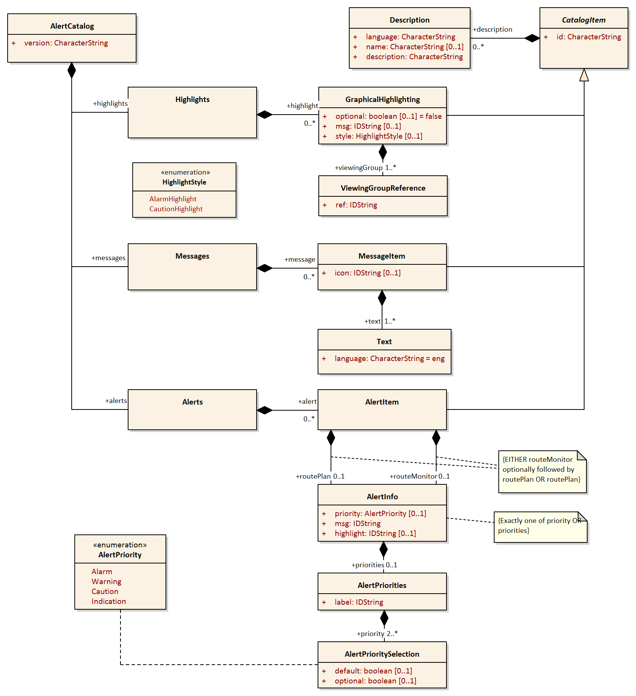
Figure 9-25 – Alert Catalogue

AlertCatalog
Role Name | Name | Description | Mult. | Type
Class | AlertCatalog | A container of all the Catalogue items | - | -
Attribute | version | The version of the Catalogue | 1 | string
Role | messages | Container of messages | 1 | Messages
Role | highlights | Container of highlights | 1 | Highlights
Role | alerts | Container of alerts | 1 | Alerts

Messages
Role Name | Name | Description | Mult. | Type
Class | Messages | A container of MessageItems | - | -
Role | message | Definition of a message | 0..* | MessageItem

MessageItem
Role Name | Name | Description | Mult. | Type
Class | MessageItem | Defines a language independent message | - | -
Subtype of | CatalogItem | See CatalogItem | - | -
Attribute | icon | Reference to a symbol in the Portrayal Catalogue | 0..1 | string
Role | text | Language specific text | 1..* | Text

Text
Role Name | Name | Description | Mult. | Type
Class | Text | Language specific string | - | -
Subtype of | string |  | - | -
Attribute | language | Identifies a language, default is eng. ISO 639-2/T alpha-3 code (eng – English, deu – German) | 0..1 | string

Highlights
Role Name | Name | Description | Mult. | Type
Class | Highlights | A container of GraphicalHighlighting items | - | -
Role | highlight | Definition of a highlight | 0..* | GraphicalHighlighting

GraphicalHighlighting
Role Name | Name | Description | Mult. | Type
Class | GraphicalHighlighting | Associates display parameters with alert information | - | -
Subtype of | CatalogItem | See CatalogItem | - | -
Attribute | style | Overrides the style of graphical highlight shown in the chart area. When empty, style is inferred from the alert priority  - Alarm: AlarmHighlight  - Others: CautionHighlight | 0..1 | HighlightStyle
Attribute | optional | Allowing the highlight to be turned off is not required. Default is false | 0..1 | boolean
Attribute | msg | A reference to a message to be displayed while any of the viewing groups are disabled | 0..1 | string
Role | viewingGroup | References viewing groups used to control graphical highlighting | 1..* | ViewingGroupReference

ViewingGroupReference
Role Name | Name | Description | Mult. | Type
Class | ViewingGroupReference | A reference to a viewing group | - | -
Role | ref | The identifier of the viewing group | 1 | string

Alerts
Role Name | Name | Description | Mult. | Type
Class | Alerts | A container of AlertItems | - | -
Role | alert | Definition of an alert | 0..* | AlertItem

AlertItem
Role Name | Name | Description | Mult. | Type
Class | AlertItem | Describes a single alert | - | -
Subtype of | CatalogItem | See CatalogItem | - | -
Role | routeMonitor | The alert behavior in route monitoring | 0..1 | AlertInfo
Role | routePlan | The alert behavior in route planning | 0..1 | AlertInfo

NOTE: The content of AlertItem is implemented in the Schema as either a routeMonitor element optionally followed by a routePlan element, or a routePlan element.

AlertInfo
Role Name | Name | Description | Mult. | Type
Class | AlertInfo | The behavior of an alert in a single mode | - | -
Role | priority | A single alert priority. If present, precludes use of priorities | 0..1 | AlertPriority
Role | priorities | A set of alert priorities. If present, precludes use of priority | 0..1 | AlertPriorities

NOTE: Exactly one of priority or priorities must be present.

AlertPriorities
Role Name | Name | Description | Mult. | Type
Class | AlertPriorities | A set of alert priorities | - | -
Attribute | label | Reference to a message used to label the UI component which allows selection of the desired alert priority | 1 | string
Role | priority | An alert priority | 2..* | AlerPrioritySelection

AlertPrioritySelection
Role Name | Name | Description | Mult. | Type
Class | AlertPrioritySelection | Adds information to an alert priority | - | -
Subtype of | AlertPriority | See AlertPriority | - | -
Attribute | default | Identifies the default priority selection. Default is false | 0..1 | boolean
Attribute | optional | Indicates allowing the user to choose this priority is optional. Default is false | 0..1 | boolean

AlertPriority
Item | Name | Description
Enumeration | AlertPriority | The priority of an alert
Value | Alarm | Indicates conditions requiring immediate attention and action by the bridge team (refer to MSC.252(83) 19.1.2)
Value | Warning | Indicates changed conditions and should be presented for precautionary reasons which are not immediately hazardous but which may become so, if no action is taken (refer to MSC.252(83) 19.1.3)
Value | Caution | Indicates a condition which does not warrant an alarm or warning condition, but still requires attention and out of the ordinary consideration of the situation or of given information (refer to MSC.252(83) 19.1.4)
Value | Indication | Display of regular information and conditions (refer to MSC.252(83) appendix 1)

HighlightStyle
Item | Name | Description
Enumeration | HighlightStyle | The style of the graphical highlight to be shown in the chart area
Value | AlarmHighlight | IEC 62288:2014 Table A.3 Navigation symbols, entry 3.5 b
Value | CautionHighlight | IEC 62288:2014 Table A.3 Navigation symbols, entry 3.5 c

Schema for pixmap files
A pixmap is a two dimensional array of pixels defining an image. This Schema allows to encode pixmaps that can be then be referenced, for example from pixmap area fills. The coordinate system for the pixmap is different than other coordinate systems in this standard. The y-axis is directed downwards and the origin is in the upper left corner of the pixmap.

Figure 9-26 – Coordinate system for pixmap
The graphic above shows a simple pixmap with width 10 pixel and height 9 pixel. Most of the pixels are transparent (here white) some pixels are coloured.
The style defines a simple type for the colour identifier:
<xs:simpleType name="ColorId">
<xs:restriction base="xs:string">
<xs:minLength value="1"></xs:minLength>
<xs:maxLength value="3"></xs:maxLength>
<xs:pattern value="[a-zA-Z0-9_]+"></xs:pattern>
</xs:restriction>
</xs:simpleType>

This describes a token 1 to 3 characters long that can contain digits, alpha characters or the underscore. It is used to identifiy a colour in the colour map.
The next type is a complex type for a pixel:
<xs:complexType name="Pixel">
<xs:simpleContent>
<xs:extension base="ColorId">
<xs:attribute name="x" type="xs:nonNegativeInteger" use="required"/>
<xs:attribute name="y" type="xs:nonNegativeInteger" use="required"/>
</xs:extension>
</xs:simpleContent>
</xs:complexType>
It extends the colour identifier and adds two attributes for the coordinate of the pixel according to the pixmap coordinate system.
Each pixmap contains a colour map; a list of colour definitions bundled with a colour identifier. Two types are defined in the Schema one for the colour map item and one for the colour map.
<xs:complexType name="ColorMapItem">
<xs:complexContent>
<xs:extension base="s100Symbol:Color">
<xs:attribute name="id" type="ColorId" use="required"/>
</xs:extension>
</xs:complexContent>
</xs:complexType>
<xs:complexType name="ColorMap">
<xs:sequence>
<xs:element name="color" type="ColorMapItem" minOccurs="1" maxOccurs="unbounded"/>
</xs:sequence>
</xs:complexType>
Note: The colour definition is taken from the S-100 symbol definition Schema. That allows using colour token from a colour profile or direct sRGB colour definitions. Transparency can be defined here as well.
The last type defined is the complex type for the pixmap itself.
<xs:complexType name="Pixmap">
<xs:sequence>
<xs:element name="description" type="xs:string" minOccurs="0" maxOccurs="1"/>
<xs:element name="width" type="xs:positiveInteger"/>
<xs:element name="height" type="xs:positiveInteger"/>
<xs:element name="colorMap" type="ColorMap">
<xs:key name="colorKey">
<xs:selector xpath="color"/>
<xs:field xpath="@id"/>
</xs:key>
</xs:element>
<xs:element name="background" type="ColorId"/>
<xs:element name="pixel" type="Pixel" minOccurs="0" maxOccurs="unbounded"/>
</xs:sequence>
</xs:complexType>
It defines an optional description element and mandatory elements for width and height. Furthermore it defines an element for the colour map, an element for the background colour and the any number of pixel elements. The background colour is implicitly used for all pixels that are not defined by a pixel element. Note that there is a key element to ensure that colour identifiers are unique.
Finally the root element is defined:
<xs:element name="pixmap" type="Pixmap">
<xs:keyref refer="colorKey" name="pixelRef">
<xs:selector xpath="pixel"/>
<xs:field xpath="."/>
</xs:keyref>
<xs:keyref refer="colorKey" name="backgroundRef">
<xs:selector xpath="background"/>
<xs:field xpath="."/>
</xs:keyref>
<xs:unique name="positionUnique">
<xs:selector xpath="pixel"/>
<xs:field xpath="@x"/>
<xs:field xpath="@y"/>
</xs:unique>
</xs:element>
The keyref element are there for ensure the referential integrity of the colour identifier used in the pixel and background element. The unique element ensures that no pixel is defined more than ones.
A complete pixmap file for the example above looks like:
<?xml version="1.0" encoding="UTF-8"?>
<pixmap xmlns:xsi="http://www.w3.org/2001/XMLSchema-instance"
xsi:noNamespaceSchemaLocation="S100Pixmap.xsd">
<description>Test pixmap showing a capital H in faint magenta.</description>
<width>10</width>
<height>9</height>
<colorMap>
<color id="_" transparency="1.0">#000000</color>
<color id="M">#8F83B6</color>
</colorMap>
<background>_</background>
<pixel x="3" y="2">M</pixel>
<pixel x="3" y="3">M</pixel>
<pixel x="3" y="4">M</pixel>
<pixel x="3" y="5">M</pixel>
<pixel x="3" y="6">M</pixel>
<pixel x="4" y="4">M</pixel>
<pixel x="5" y="4">M</pixel>
<pixel x="6" y="2">M</pixel>
<pixel x="6" y="3">M</pixel>
<pixel x="6" y="4">M</pixel>
<pixel x="6" y="5">M</pixel>
<pixel x="6" y="6">M</pixel>
</pixmap>

Page intentionally left blank

Appendix 9-A

Generating Portrayal Input XML (informative)

Preface
This standard describes a base Schema that contains base types which define the expected structure of the XML input to the portrayal processing. The XSLT portrayal rules expect the input XML to conform with the base Schema, with additional information as defined within a product‘s Feature Catalogue.
Although the encoded elements of the input XML must conform to the base Schema, it is not necessary to fully describe a Schema for each product‘s input XML. It is sufficient that the portrayal rules can consistently parse the input XML using XPath 1.0 queries.
The base Schema should be used along with patterns described in this Appendix to model a generic pattern for describing all S-100 content; essentially providing a mapping from the S-100 general feature model to an XML encoding of an instance of the model.
This section describes how the input XML should be generated. Patterns will be introduced to map the data model from a Feature Catalogue to an input XML for portrayal. Although the input XML can cover the entire data model it is sufficient to generate only the part that is relevant for portrayal.

Input XML structure
The input XML must conform to the following structure, using the indicated element names and order.
<!—The root element -->
<Dataset>
<InformationTypes>
</InformationTypes>

<!—Spatial Objects -->
<Points>
</Points>
<MultiPoints>
</MultiPoints>
<Curves>
</Curves>
<CompositeCurves>
</CompositeCurves>
<Surfaces>
</Surfaces>

<Features>
</Features>
</Dataset>

Simple attributes
When encoding simple attributes the element name should match the code of a simple attribute defined within the product‘s Feature Catalogue. For enumerations, the code should be passed as the value, the label should not be used.
<colour>3</colour> <!—don’t encode as red -->

Complex attributes
When encoding complex attributes the element name should match the code of a complex attribute defined within the product‘s Feature Catalogue. Simple and/or complex sub attributes should be nested within the element.
An instance of complex attribute “speed“ with simple sub attributes “speedMaximum“ and “speedMinimum“:
<speed>
<speedMaximum>10</speedMaximum>
<speedMinimum>0</ speedMinimum>
</speed>

Information types
Instances of information types are encoded within the <InformationTypes> section of the input XML. Information types are referenced by other objects encoded in the input XML.
The base Schema defines abstract type Information for encoding of information types. The following pattern describes instantiation of the abstract type:
- The element name of each information type object must match the code of an InformationType defined in the product’s Feature Catalogue. The code defines the instantiation of the abstract type; in the example below, ChartNote is the instantiation of Information.
- The value(s) of the attributes of the information type should be included in the encoding, as described in clauses 9-A-2 and 9-A-3. These values should be nested within the element described by the preceding bullet (they are part of the instantiation).
Notional information type ChartNote, described in the Feature Catalogue as having complex attribute note, which has simple sub attributes noteText and language:
<ChartNote id="I1">
<note>
<noteText>Hello world!</noteText>
<language>en</language>
</note>
<note>
<noteText>Hallo Welt!</noteText>
<language>de</language>
</note>
</ChartNote>

Spatial objects
The base Schema defines spatial types which describe XML encodings of the Part 7 Spatial Schema. These types provide a consistent way to represent spatial objects to the portrayal processing. The input XML encoding of spatial objects should conform with the base Schema; the spatial model cannot be modified by a product‘s Feature Catalogue.
In most cases the portrayal rules do not attempt to reference the geometry coordinates of spatial objects; in these cases the geometry coordinates may be omitted from the input XML, potentially providing significant advantages to the speed of generating and parsing the input XML. A notable exception when the geometry coordinates cannot be omitted is symbolization of MultiPoint spatial objects, as geometry coordinates should always be provided for MultiPoint spatial objects.

Features
Instances of feature types are encoded within the <Features> section of the input XML.
The base Schema defines abstract type Feature for encoding of feature objects. The following pattern describes instantiation of the abstract type:
- The element name of each feature object must match the code of a feature type defined in the product‘s Feature Catalogue. The code defines the instantiation of the abstract type; in the example below, BeaconLateral is the instantiation of Feature.
- The value(s) of the attributes of the feature object should normally be included in the encoding, as described in clauses 9-A-2 and 9-A-3. These values should be nested within the element described by the preceding bullet (they are part of the instantiation). Attribute values provided via Coverages should be omitted from the encoding.
- All references to spatial objects should be included as described in the base Schema.
- All associations to information type instances and feature instances should be included, as described in clause 9-A-7.
An example encoding of an instance of a BeaconLateral feature. The feature references a spatial object of type Point (P23), and has an association to a feature instance (F8) which should also be described in the input XML, but is not shown in this example. The value of each of the features attributes is also encoded.
<BeaconLateral id="F4" primitive=”Point” >
<Point ref="P23" scaleMinimum=“4294967295” scaleMaximum=”0” />
<beaconShape>1</beaconShape>
<categoryOfLateralMark>2</categoryOfLateralMark>
<colour>3</colour>
<reportedDate>20050124</reportedDate>
<status>1</status>
<scaleMinimum>89999</scaleMinimum>
<StructureEquipment role=”supports” featureRef=”F8” />
</BeaconLateral>

Associations
Associations are named relationships between objects. There are two types of associations: information associations for relationships between any object and an information type, and feature associations for relationships between two feature types.
The base Schema provides element associatedInformation as part of any object, and provides element associatedFeature as part of feature objects. The pattern for encoding associations is:
- The element name of each association must match the code of an association defined in the product’s Feature Catalogue. The code describes the subtype of the association; in the example below, StructureEquipment replaces associatedFeature from the base Schema and describes the relationship between the two feature objects.
- The value of the role attribute should match a role described in the Feature Catalogue.
- The value of featureRef (for feature associations) or informationRef (for information associations) should match the unique id of a feature instance or information type instance encoded within the input XML.
- Include the values of any simple or complex attributes which are defined for the association as described in the Feature Catalogue. These values should be nested within the association element.
An example feature association: StructureEquipment. The association should be nested within the encoding of a feature instance.
<Features>
<FeatureTypeX id="F1" primitive=”Point” >
<!-- feature attributes and spatial reference omitted -->
<StructureEquipment role=”supports” featureRef=”F2”/>
</FeatureTypeX>
<FeatureTypeY id="F2" primitive=”Point” >
<!-- feature attributes and spatial reference omitted -->
<StructureEquipment role=”supportedBy” featureRef=”F1” />
</FeatureTypeY>
</Features>
An example information association: An instance of a SpatialQuality information type referenced from a spatial object using a SpatialAssociation InformationAssociation type:
<InformationTypes>
<SpatialQuality id="I1">
<qualityOfHorizontalMeasurement>4</qualityOfHorizontalMeasurement>
</SpatialQuality>
</InformationTypes>
<Points>
<Point id="P1">
<SpatialAssociation role=”defines” informationRef=”I1” />
<Coordinate2D>
<x>0.0</x>
<y>1.0</y>
</Coordinate2D>
</Point>
</Points>

Page intentionally left blank

Appendix 9-B

SVG Profile (normative)

Introduction
This appendix describes the subset of SVG elements, attributes and properties which may be used within an S-100 compliant SVG document.
The goal is to limit the effort for an OEM to render the symbols on the one hand and give the symbol designers enough flexibility to use the common design techniques to create the symbols on the other hand. It should be possible to use SVG editors as they are available on the market.
The S-100 SVG Profile is a subset of the SVG Tiny 1.2 Profile
http://www.w3.org/TR/SVGTiny12/

Document structure

The top-level element
SVG documents that comply with this specification must have an <svg> element as the root element. This is the only <svg> element allowed in the document.
The following attributes can be used on the <svg> element to describe the properties of the SVG symbol:
Table 9-B-1 – <svg> attributes
Attribute | Description | Use | Remarks
xmlns | The namespace URI of SVG | required | Fixed to:  http://www.w3.org/2000/svg
version | The language version of SVG | required | Fixed to: 1.2
baseProfile | The base profile used | required | Fixed to: tiny
xml:space | Defines the space handling | optional | Default: preserve
width | The intrinsic width of the symbol | required | Must be given in mm
height | The intrinsic height of the symbol | required | Must be given in mm
viewBox | Defines the user coordinate system and the range of allowed coordinates | required | See clause 9-B-3.1 for more details

The presentation attributes can be used at the <svg> element as well as they can be used on any element in an SVG file. See clause 9-B-4.1 for a list of possible attributes.
Example:
<svg xmlns="http://www.w3.org/2000/svg" version="1.2" baseProfile="tiny" xml:space="preserve" width="4.34mm" height="5.35mm" viewBox="-2.22 -2.79 4.34 5.35">

Supported elements
The following elements are supported to comply with this specification:
Table 9-B-2 – Supported elements
Element | Multiplicity | Description | Remarks
<title> | 0..1 | The name of the symbol | See the example below
<desc> | 0..1 | The brief textual description of the symbol | See the example below
<metadata> | 0..1 | Metadata according to the S-100 SVG Metadata schema | See clause 9-B-2.3
<g> | 0..* | Container element | Can have all the following elements and other <g> elements as children
<rect> | 0..* | Shape element for rectangle | See clause 9-B-5.3 for more details
<circle> | 0..* | Shape element for circle | See clause 9-B-5.4 for more details
<ellipse> | 0..* | Shape element for ellipse | See clause 9-B-5.5 for more details
<line> | 0..* | Shape element for a straight-line segment | See clause 9-B-5.2 for more details
<polyline> | 0..* | Shape for a set of straight-line connected segments | See clause 9-B-5.6 for more details
<polygon> | 0..* | Shape that describes a closed set of connected straight-line segments | See clause 9-B-5.7 for more details
<path> | 0..* | Outline of a shape that can be filled or stroked. The outline can be curved | See clause 9-B-5.1 for more details.

Example of a <title> element:
<title>ACHARE02</title>
Example of a <desc> element:
<desc>anchorage area as a point at small scale, or anchor points of mooring trot at large scale</desc>

Metadata

SVG has a metadata element which allows for the direct inclusion of metadata document fragments from other namespaces.
For this profile the element is defined in a schema assigned to the namespace:
http://www.iho.int/SVGMetadata/5.2
It defines an element <S100SVG> with the following attributes:
Table 9-B-3 – <S100SVG attributes>
Attribute | Use | Type | Description
publisher | required | xs:string | The name of the publisher
creationDate | required | xs:date | The date of creation
source | optional | xs:string | The source of the symbol (for example S-52)
format | optional | xs:string | The format used
version | required | xs:decimal | The version of this symbol

Example:
<metadata>
<iho:S100SVG xmlns:iho="http://www.iho.int/SVGMetadata/5.2">
<iho:Description iho:publisher="IHO" iho:creationDate="2014-06-19" iho:source="S52Preslib4.0" iho:format="S100SVG" iho:version="1.0"/>
</iho:S100SVG>
</metadata>

Coordinates

The initial user coordinate system
The initial user coordinate system is defined by the width, height, and viewport attributes of the <svg> element. All coordinates used in the document are based on this coordinate system. Note that within the document the user coordinate system can be modified with the transform attribute. See clause 9-B-3.2 for details.
The viewport of the symbol is defined with the attributes width and height at the <svg> element. The values must be given in millimetres.
Example:
<svg … width="4.34mm" height="5.35mm" …>
The viewBox attribute defines which range of coordinates the user can use in that viewport. It must be formatted as a list of four numbers (min-x min-y width height), separated by white space and/or a comma.
The coordinate system used for SVG has the x-axis pointing to the right and the y-axis pointing down.
The pivot point of the symbol is always at the 0,0 position.
Example:
<svg width="4mm" height="5.5mm" viewBox="0 0 4 5.5" …>
Defines a physical viewport of 4x5.5 millimetres and maps it to a coordinate space from 0.0 to 4.0 for the x-coordinates and from 0.0 to 5.5 for the y-coordinates. The coordinate (0, 0) – which defines the pivot point – is at the upper left corner of the symbol.
Each unit in the initial user coordinate system is equivalent to 1 millimetre.
Another example:
<svg width="10mm" height="10mm" viewBox="-50 -50 100 100" …>
Here the x-coordinates can range from -50 to +50 and the y-coordinates can range from -50 to +50 to span the viewport of 10mm for both dimensions. The pivot point is located in the centre of the area and each user defined unit corresponds to a tenth of a millimetre.
The mapping of that coordinate range to the physical dimension takes the aspect ratio into account. The preserveAspectRatio attribute is not supported by this profile; thus its default value must be used by any renderer. This value is: “xMidYMid”.
It is recommended that the ratio of the width and height components of the viewbox is identical to the ratio of the width and height of the viewport. Otherwise, the viewbox will not fill the entire viewport. Both viewbox and physical space will be aligned at their centres and the viewbox is uniformly scaled so that it fits completely inside the viewport.
To summarize:
- The width and height of the viewport must be defined in millimetres.
- It is recommended that the width and height of the viewbox have the same ratio as the width and height of the viewport.
- The min-x and min-y coordinates of the viewbox must be chosen in a way that the pivot point (0, 0) is situated at the corresponding part of the symbol’s graphic.

Transformations
A new user coordinate system can be established by specifying transformations in the form of a 'transform' attribute on a container or a graphics element.
The transform attribute can have either the value ‘none’ or a list of affine transformations.
If ‘none’ is specified, the identity transformation is defined. This is identical to not specifying the attribute at all.
The transformation list consists of single transformation elements separated by white spaces and/or a comma.
The transformation commands are:
- Translation: translate(tx [ty])
A translation by tx and ty. If ty is not given it is assumed to be 0.
Matrix: 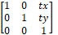
Example: translate(20 30)
- Scaling: scale(sx [sy])
A scale operation by sx and sy. If sy is not given it is assumed to be equal to sx.
Matrix: 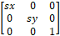
Examples: scale(3 2) scale(0.5)
- Rotation: rotate(α [cx cy])
A rotation by α degrees around the point (cx, cy)
Matrix: 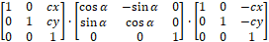
Examples: rotate(30) rotate(-45 120 30)
- Skewing: skewX(α) and skewY(α)
A skew transformation along the x-axis or the y-axis.
Matrix: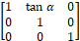 for skewing along the x-axis or 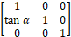 along the y-axis.
Examples: skewX(20) skewY(15)
- Matrix: matrix(a b c d e f)
A generic affine transformation
Matrix: 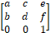
The coordinate transformation is defined by:
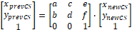
Transformation can be nested by multiplying the corresponding matrices.
All defined transformations define the Current Transformation Matrix (CTM):
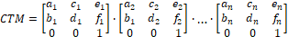
That leads to the following equation for transforming user coordinates to viewport coordinates:
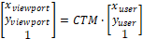

Styling

Styling-properties
The following styling properties are included in this profile. Renderers must support them to be compliant with the profile.
For each styling property defined in this specification, there is a corresponding XML attribute (the presentation attribute) with the same name that is available on all relevant SVG elements.
For example, SVG has a 'fill' property that defines how to paint the interior of a shape. There is a corresponding presentation attribute with the same name (that is, 'fill') that can be used to specify a value for the 'fill' property on a given element.
The following example shows how the 'fill' and 'stroke' properties can be assigned to a rectangle using the 'fill' and 'stroke' presentation attributes. The rectangle will be filled with red and outlined with blue:
<?xml version="1.0"?>
<svg xmlns="http://www.w3.org/2000/svg" version="1.2" baseProfile="tiny"
width="10mm" height="5mm" viewBox="0 0 1000 500">
<rect x="200" y="100" width="600" height="300" fill="red" stroke="blue" stroke-width="3"/>
</svg>
All presentation attributes can be used at the <svg> element, the <g> element, and on any shape element used in the SVG file. If it is used at the <svg> element or the <g> element the values will be inherited to all child elements of these elements. If defined at a child element this value overrides the value from the container element.
The following Table describes the style properties supported by this profile.
Table 9-B-4 – Style properties
Property | Initial value | Description | Remarks
fill | black | Describes the colour that is used to fill the interior of a shape. The value ‘none’ indicates the shape should be not filled. | Applies to all shapes but has no effect for <line>  See notes on colours below
fill-opacity | 1 | Specifies the opacity to be used for the filling of the interior of a shape. Values must be between 0 (fully transparent) and 1 (fully opaque). | Applies to all shapes but has no effect for <line>
fill-rule | nonzero | Describes the algorithm to identify which part of a shape must be filled.  Possible values are:  - nonzero  - evenodd | See below
stroke | none | Describes the colour to be used for the rendering of the outline of the graphical element where it is used. The value none indicates that the outline should not be rendered. | See notes on colours below
stroke-opacity | 1 | Specifies the opacity to be used for the stroke.
stroke-width | 1 | The width of the stroke. | The width is related to the local user coordinate system applicable to the element
stroke-linecap | butt | 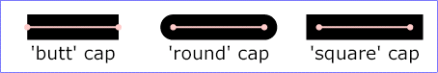  Specifies the shape to be used at the end of open subpaths when they are stroked.
stroke-linejoin | miter | Specifies the shape to be used at the corners of shapes when they are stroked.  
stroke-miterlimit | 4 | When the line join is miter and the ratio between the miter length and the stroke width exceeds this value the linejoin should be converted from miter to bevel.  The miter length is the distance between the outer tip and the inner corner of the miter. | The ratio of miter length to 'stroke-width' is directly related to the angle (θ) between the segments in user space by the formula:  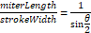
stroke-dasharray | none | Specifies the pattern of dashes and gaps that shall be used to stroke paths. It is either a list of lengths or ‘none’. ‘none’ means that the stroke is drawn continuously. Line caps apply at both ends of each stroke. | If the number of lengths is odd the list should be internally duplicated.  For example, 1,2,3 becomes 1,2,3,1,2,3
stroke-dashoffset | 0 | Specifies the distance into the dash pattern that must be used to start the dash.
shape-rendering | auto | The creator of SVG content might want to provide a hint to the implementation about what trade-offs to make as it renders vector graphics elements such as 'path' elements and basic shapes such as circles and rectangles. The 'shape-rendering' property provides these hints.  Possible values are:  - auto  - optimizeSpeed  - crispEdges  - geometricPrecision | See below.
display | inline | Defines whether an element is to be rendered or not.  Allowed values for this profile:  - inline : will be rendered  - none: will not be rendered | Can be used to include elements that do not belong to the symbol itself but may be visible in engineering drawings (pivot point, viewbox, etc)

Colours: The rendering of symbols in systems like ECDIS requires that colours are not specified explicitly. They will be defined by colour-tokens instead. The tokens will be translated to SRGB values by means of style-sheets. See clause 9-B-4.4 for more details.
NOTE: In converting CIE to sRGB, the rendering intent must follow an absolute colorimetry method. Due to the differences in colour and luminance performance between individual monitors, any “formula“ for conversion from CIE to sRGB must be based on measurements to characterize (calibrate) the monitor in order to meet the colour accuracy and separation specified for ECDIS. For interoperability with ECDIS, portrayal of other S-1xx products would need to follow the same rendering intent. This may mean that the assignment from colour token to RGB values might be overridden by an ECDIS system to the hardware dependent values and the values from the CSS file are only there as a fall back.
fill-rule: For a simple, non-intersecting path, it is intuitively clear what region lies "inside"; however for a more complex path, such as a path that intersects itself or where one sub-path encloses another, the interpretation of "inside" is not so obvious.
The two options are defined as follows:
Table 9-B-5 – ‘fill-rule’ – options
nonzero | evenodd
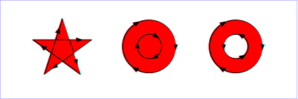  Draw a ray from the point to infinity in any direction and then examine the places where a segment of the shape crosses the ray. Starting with a count of zero, add one each time a path segment crosses the ray from left to right and subtract one each time a path segment crosses the ray from right to left. After counting the crossings, if the result is zero then the point is outside the path. Otherwise, it is inside. | Draw a ray from the point to infinity in any direction and counting the number of path segments from the given shape that the ray crosses. If this number is odd, the point is inside; if even, the point is outside.  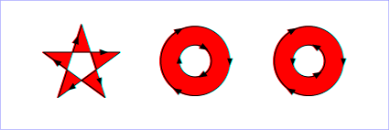

shape-rendering: The hints for the property ‘shape-rendering’ are defined as follows:
Table 9-B-6 – ‘shape-rendering’ – options
auto | Indicates that the user agent shall make appropriate trade-offs to balance speed, crisp edges and geometric precision, but with geometric precision given more importance than speed and crisp edges.
optimizeSpeed | Indicates that the user agent shall emphasize rendering speed over geometric precision and crisp edges. This option will sometimes cause the user agent to turn off shape anti-aliasing.
crispEdges | Indicates that the user agent shall attempt to emphasize the contrast between clean edges of artwork over rendering speed and geometric precision. To achieve crisp edges, the user agent might turn off anti-aliasing for all lines and curves or possibly just for straight lines which are close to vertical or horizontal. Also, the user agent might adjust line positions and line widths to align edges with device pixels.
geometricPrecision | Indicates that the user agent shall emphasize geometric precision over speed and crisp edges.

The ‘style’ attribute
The ‘style’ attribute is part of SVG 1.1, but is not supported by SVG tiny and therefore cannot be used by this profile. Nevertheless, it was allowed in previous versions of this standard.
Robust parsers and renderers may interpret the content of the style attribute. A style attribute uses CSS inline styling to specify the display properties.

The ‘class’ attribute
The ‘class’ attribute is used to assign one or more class names to an element. In the S-100 SVG Profile the class attribute is used to assign style information by way of a Cascading Style Sheet (CSS). It can also be used to filter or control which elements should be shown. Essentially the class tokens can be used as a key to find a set of style instructions in the corresponding CSS. A processing instruction at the head of the SVG symbol indicates the corresponding CSS file.
Example:
<?xml-stylesheet href="MyStyle.css" type="text/css"?>

CSS
The Cascading Style Sheet (CSS) mechanism allows for the possibility to change styling properties by means of a CSS file.
Though the mechanism allows modification of all styling-properties the mechanism must only be used for two use cases.
- The colour properties ‘fill’ and ‘stroke’
- The visibility of elements that do not belong to the symbol but may be used for engineering diagrams (for example, the pivot point and the initial viewbox)
All symbols should be designed in a way that they can be viewed:
- by third party tools that do not support CSS
- in the absence of the appropriate CSS file.
How this can be achieved is demonstrated in the following example.
An excerpt of a CSS file (MyStyle.css) is defined as follows:
/* Set to 'inline' to show viewbox and pivot point or to 'none' to hide them */
.layout {display: inline}

.svgBox {fill: none; stroke: blue;}
.pivotPoint {fill: none; stroke: red;}

.fNone {fill: none}
.sNone {stroke: none}
.fNODTA {fill: #93AEBB}
.sCURSR {stroke: #E38039}
.fCURSR {fill: #E38039}
.sCHBLK {stroke: #000000}
.fCHBLK {fill: #000000}
.sCHYLW {stroke: #E1E139}
.fCHYLW {fill: #E1E139}
...
For each colour token two classes are defined: One for the stroke property and the other for the fill property. In addition, there are classes for fill=”none” and stroke=”none” and classes that control the colours and the display for the pivotPoint and the svgbox.
The symbol is defined as:
<?xml version="1.0" encoding="UTF-8" standalone="no"?>
<?xml-stylesheet href="style.css" type="text/css"?>
<svg xmlns="http://www.w3.org/2000/svg" version="1.2" baseProfile="tiny"
width="70mm" height="70mm" viewBox="-350 -350 700 700" >

<g stroke="#000000" stroke-width="10" fill="#E1E139" class="fCHYLW sCHBLK">
<circle cx="0" cy="-50" r="75"/>
<circle cx="-35" cy="-70" r="10" stroke="none" fill="#000000" class="sNone fCHBLK"/>
<circle cx="35" cy="-70" r="10" stroke="none" fill="#000000" class="sNone fCHBLK"/>
<path d="M -40,-20 C -20,-40 20,-40 40,-20" fill="none" class="fNone" transform="rotate(180 0 -20)"/>
</g>

<g display="none" stroke-width="1" fill="none" class="layout">
<!-- viewBox-->
<rect x="-349.5" y="-349.5" height="699" width="699" stroke="blue" class="svgBox"/>
<!-- pivot point -->
<g stroke="red" class="pivotPoint">
<circle cx="0" cy="0" r="20"/>
<line x1="0" y1="-50" x2="0" y2="50"/>
<line x1="-50" y1="0" x2="50" y2="0"/>
</g>
</g>
</svg>
The first <g> element defines the stroke and fill property as fill="#E1E139" (yellow) and stroke="#000000" (black). In addition, it assigns the class to class="fCHYLW sCHBLK".
The latter assigns the fill and stroke properties to the values in the CSS file. Here the values are the same but in a different CSS file (for example, for night view) different values may be defined.
The first <circle> element defines no a circle which inherits these properties; that is, a circle with an black outline and a yellow fill.
The next two <circle> elements override the fill and stroke values to: stroke="none" fill="#000000" and the class to class="sNone fCHBLK". Both circles will be rendered with a black fill an no outline.
The <path> element overrides the fill value only to fill="none" and the class to class="fNone". The path will be rendered with a black stroke, and it will not be filled.
The second <g> element in the file defines the elements for the pivot point and the view box. If the symbol is rendered by using the CSS file the display property will be changed from none to inline, and in this case the elements are visible. If the symbol is rendered without the use of the CSS the elements will not be visible.

If the symbol is rendered using the style sheet the result will be:

If the CSS file is not used the pivot point and viewbox will not be visible.

Drawing Elements

Path
A path represents the outline of a shape which can be filled or stroked.
A path is described using the concept of a current point. In an analogy with drawing on paper, the current point can be thought of as the location of the pen. The position of the pen can be changed, and the outline of a shape (open or closed) can be traced by dragging the pen in either straight lines or curves.
The path element can carry all presentation attributes, the class attribute, the transform attribute and as a path specific attribute the d attribute.
The d attribute defines the outline of the shape and consists of moveTo, line, curve, and closePath commands.
Examples:
<path d="M -2.06,1.36 L -1,2.4 L 0.98,2.4 L 1.96,1.39"
class="sCHMGD" stroke="#c045d1" stroke-width="0.32"/>
<path d="M -5.88,-5.88 L 5.87,-5.88 L 5.87,5.87 L -5.88,5.87 L -5.88,-5.88 Z"
class="fDNGHL" fill="#ea5471" fill-opacity="0.25"/>
All commands are defined by a single letter followed by a list of coordinates. All commands are available for absolute coordinates (uppercase letters) and for relative coordinates (lowercase letters). The relative coordinates are defined relative to the current point (cpx cpy) The absolute coordinates for relative coordinates (x y) are (cpx+x cpy+y)
All coordinates are coordinates of the local user space; that is, transformations must be taken into account.

MoveTo commands
Command | Parameter | Description
M (absolute)  m (relative) | (x y)+ | Start a new sub-path at the given (x,y) coordinate. M (uppercase) indicates that absolute coordinates will follow; m (lowercase) indicates that relative coordinates will follow. If a moveto is followed by multiple pairs of coordinates, the subsequent pairs are treated as implicit lineto commands. Hence, implicit lineto commands will be relative if the moveto is relative, and absolute if the moveto is absolute. If a relative moveto (m) appears as the first element of the path, then it is treated as a pair of absolute coordinates. In this case, subsequent pairs of coordinates are treated as relative even though the initial moveto is interpreted as an absolute moveto.

ClosePath commands
Command | Parameter | Description
Z (absolute)  z (relative) | (none) | The current sub-path shall be closed by drawing a straight line from the current point to current subpath's initial point, which then shall become the new current point. Since the Z and z commands take no parameters, they have an identical effect.

LineTo commands
Command | Parameter | Description
L (absolute)  l (relative) | (x y)+ | Draws a straight line from the current point to (x, y) and set the current point to this position. If multiple coordinate pairs are given this is repeated.  L x1 y1 x2 y2 is equivalent to L x1 y1 L x2 y2 and  l x1 y1 x2 y2 is equivalent to l x1 y1 l x2 y2
H (absolute)  h (relative) | x+ | Draws a horizontal line to (x cpy) and set the current point to this position.
V (absolute)  v (relative) | y+ | Draws a vertical line to (cpx y) and set the current point to this position

Example:
<svg xmlns="http://www.w3.org/2000/svg" version="1.2" baseProfile="tiny"
width="60mm" height="30mm" viewBox="-300 -150 600 300">
<path d="M -240 120 L 0 -40 240 120" fill="none" stroke="black" stroke-width="10"/>
<path d="M -240 40 l 240 -160 240 160" fill="none" stroke="green" stroke-width="10"/>
<path d="M -200 120 h 200 v-100" fill="none" stroke="red" stroke-width="10"/>
<rect x="-299.5" y="-149.5" height="299" width="599" stroke="blue" fill="none"/>
</svg>
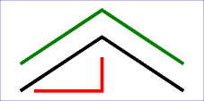

Curve commands
Command | Parameter | Description
C (absolute)  c (relative) | (x1 y1 x2 y2 x y)+ | A cubic Bézier curve shall be drawn from the current point to (x,y) using (x1,y1) as the control point at the beginning of the curve and (x2,y2) as the control point at the end of the curve.  The current point is then set to (x,y). If multiple sets of coordinates are specified this is repeated.
S (abolute)  s (relative) | (x2 y2 x y)+ | A cubic Bézier curve shall be drawn from the current point to (x,y). The first control point shall be the reflection of the second control point on the previous command relative to the current point. (If there is no previous command or if the previous command was not a C, c, S or s, the first control point shall be coincident with the current point.) (x2,y2) shall be used as the second control point (i.e., the control point at the end of the curve). If multiple sets of coordinates are specified, a polybézier shall be drawn. At the end of the command, the new current point shall be the final (x,y) coordinate pair used in the polybézier.
Q (absolute)  q (relative) | (x1 y1 x y)+ | A quadratic Bézier curve is drawn from the current point to (x,y) using (x1,y1) as the control point. Then the current point is set to (x,y). If multiple sets of coordinates are specified this is repeated.
T (absolute)  t (relative) | (x y)+ | The same as the Q, q command except the control point shall be the reflection of the control point on the previous command relative to the current point. If there is no previous command or if the previous command was not a Q, q, T or t, the control point shall be the current point.

Example for a path using cubic Bézier curves:
<?xml version="1.0" encoding="UTF-8" standalone="no"?>
<svg xmlns="http://www.w3.org/2000/svg" version="1.2" baseProfile="tiny"
width="60mm" height="30mm" viewBox="-300 -150 600 300" >
<path d="M-240 0 C -240 -120 -40 -120 0 0 S 240 120 240 0"
fill="none" stroke="black" stroke-width="10"/>
<g fill="red" stroke="none">
<line x1="-240" y1="0" x2="-240" y2="-120" stroke="blue"/>
<circle cx="-240" cy="0" r="10"/>
<circle cx="-240" cy="-120" r="10"/>
<line x1="-40" y1="-120" x2="0" y2="0" stroke="blue"/>
<circle cx="-40" cy="-120" r="10"/>
<circle cx="0" cy="0" r="10"/>
<line x1="0" y1="0" x2="40" y2="120" stroke="blue"/>
<circle cx="40" cy="120" r="10" fill="none" stroke="red" stroke-width="3"/>
<line x1="240" y1="0" x2="240" y2="120" stroke="blue"/>
<circle cx="240" cy="0" r="10"/>
<circle cx="240" cy="120" r="10"/>
</g>
<rect x="-299.5" y="-149.5" height="299" width="599" stroke="blue" fill="none"/>
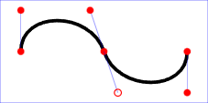
</svg>

Line
The <line> element defines a line segment that starts at one point and ends at another.
The <line> element can carry all presentation attributes, the class attribute, the transform attribute and the following specific attributes:
Table 9-B-7 – Line-specific attributes
Attribute | Initial value | Description
x1 | 0 | The x-coordinate of the start point of the line in user space coordinates
y1 | 0 | The y-coordinate of the start point of the line in user space coordinates
x2 | 0 | The x-coordinate of the end point of the line in user space coordinates
y2 | 0 | The y-coordinate of the end point of the line in user space coordinates

Example:
<line x1="-240" y1="0" x2="-240" y2="-120" stroke="blue"/>

Rectangle
The <rect> element defines a rectangle which is axis-aligned with the current user coordinate system. Rounded rectangles can be achieved by setting appropriate values for attributes rx and ry.
The <rect> element can carry all presentation attributes, the class attribute, the transform attribute and the following specific attributes:
Table 9-B-8 – Rectangle-specific attributes
Attribute | Initial value | Description
x | 0 | The x-axis coordinate of the side of the rectangle which has the smaller x-axis coordinate value in the current user coordinate system
y | 0 | The y-axis coordinate of the side of the rectangle which has the smaller y-axis coordinate value in the current user coordinate system
width | 0 | The width of the rectangle
height | 0 | The height of the rectangle
rx | 0 | For rounded rectangles, the x-axis radius of the ellipse used to round off the corners of the rectangle
ry | 0 | For rounded rectangles, the y-axis radius of the ellipse used to round off the corners of the rectangle

Circle
The <circle> element defines a circle based on a centre point and a radius.
The <circle> element can carry all presentation attributes, the class attribute, the transform attribute and the following specific attributes:
Table 9-B-9 – Circle-specific attributes
Attribute | Initial value | Description
cx | 0 | The x-axis coordinate of the centre of the circle in the current user coordinate system
cy | 0 | The y-axis coordinate of the centre of the circle in the current user coordinate system
r | 0 | The radius of the circle

Ellipse
The <ellipse> element defines an ellipse which is axis-aligned with the current user coordinate system based on a centre point and two radii.
The <ellipse> element can carry all presentation attributes, the class attribute, the transform attribute and the following specific attributes:
Table 9-B-10 – Ellipse-specific attributes
Attribute | Initial value | Description
cx | 0 | The x-axis coordinate of the centre of the ellipse in the current user coordinate system
cy | 0 | The y-axis coordinate of the centre of the ellipse in the current user coordinate system
rx | 0 | The x-axis radius of the ellipse
ry | 0 | The y-axis radius of the ellipse

Polyline
The <polyline> element defines a set of connected straight line segments. Typically, <polyline> elements define open shapes.
The <polyline> element can carry all presentation attributes, the class attribute, the transform attribute and the following specific attributes:
Table 9-B-11 – Polyline-specific attributes
Attribute | Initial value | Description
points | (empty) | A list of coordinates that taken pairwise make up the polyline. Coordinates are separated by whitespaces and/or a comma. The number of coordinates must be even, otherwise the attribute should be treated as if the attribute has not been specified

Note that the element can be filled but even if the polyline is closed (first and last point are identical) the line-join property will not be taken into account at this point. It is recommended that the element <polygon> or <path> is used for filled shapes.
Example:
<?xml version="1.0" encoding="UTF-8" standalone="no"?>
<svg xmlns="http://www.w3.org/2000/svg" version="1.2" baseProfile="tiny"
width="60mm" height="30mm" viewBox="-300 -150 600 300" >
<polyline points="-275,0 -250,0 -250,-25 -200,-25 -200,0
-150,0 -150,-50 -100,-50 -100,0 -50,0
-50,-75 0,-75 0,0 25,0" stroke="black"
fill="none" stroke-width="5"/>
<rect x="-299.5" y="-149.5" height="299" width="599"
stroke="blue" fill="red" fill-opacity="0.1"/></svg>
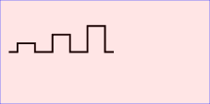
</svg>

Polygon
The <polygon> element defines a closed shape consisting of a set of connected straight line segments.
The <polygon> element can carry all presentation attributes, the class attribute, the transform attribute and the following specific attributes:
Table 9-B-12 – Polygon-specific attributes
Attribute | Initial value | Description
points | (empty) | A list of coordinates that taken pairwise make up the polygon. Coordinates are separated by whitespaces and/or a comma. The number of coordinates must be even, otherwise the attribute should be treated as if the attribute has not been specified

A 'polygon' element must be rendered in a way that produces the same result as if the following path were specified instead:
- Perform an absolute moveto operation to the first coordinate pair in the list of points.
- For each subsequent coordinate pair, perform an absolute lineto operation to that coordinate pair.
- Perform a closepath command.
Example:
<?xml version="1.0" encoding="UTF-8" standalone="no"?>
<svg xmlns="http://www.w3.org/2000/svg" version="1.2" baseProfile="tiny"
width="60mm" height="30mm" viewBox="-300 -150 600 300" >
<g fill="#00ff00" fill-rule="evenodd" stroke="black" stroke-width="5">
<polygon points="0,-85.1 50,68.8 -80.9,-26.3 80.9,-26.3 -50,68.8"
transform="translate(-100 0)"/>
<polygon points="0,-85.1 80.9,-26.3 50,68.8 -50,68.8 -80.9,-26.3"
transform="translate(100 0)"/>
</g>
<rect x="-299.5" y="-149.5" height="299" width="599" stroke="blue" fill="none"/>
</svg>
